**3U CUBESAT FOR EARTH OBSERVATION**

**A GRADUATION PROJECT REPORT**

*Submitted by*

|  |  |
| --- | --- |
| Ahmed Abdelhamid Mohammed |  |
| Ahmed Tarek Ahmed Yousef |  |
| Ali Salama Hussien Elsakka |  |
| Elhassan Abdelmeged Mohamed |  |
| Mahran Sayed Kassem Ali |  |
| Mohab Ahmed Mohamed Abd El-Hakim |  |
| Mostafa Mohi El deen Salah |  |
| Walaa Mahmoud Yehia Mahmoud | 9203698 |

*Submitted to the*

FACULTY OF AERONAUTICAL AND AEROSPACE ENGINEERING AT CAIRO UNIVERSITY

*in partial fulfillment of the requirements for the award of the degree of*

BACHELOR OF ENGINEERING

In

AERONAUTICAL AND AEROSPACE ENGINEERING

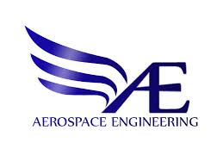

*Submitted to the*

*Under the supervision of*

Dr. Mohamed Khalil Ibrahim Dr. Ayman Hamdy Kassem

***JULY 2024***

**ACKNOWLEDGEMENTS**

**ABSTRACT**

***Keywords:***

**Preface**

**Nomenclatures**

|  |  |
| --- | --- |
|  |  |
|  |  |
|  |  |
|  |  |
|  |  |
|  |  |
|  |  |
|  |  |

**Acronyms**

|  |  |
| --- | --- |
|  |  |
|  |  |
|  |  |
|  |  |
|  |  |
|  |  |
|  |  |
|  |  |

**CONTENTS**

1. INTRODUCTION 1

2. LITERATURE REVIEW 2

3. MISSION ANALYSIS 3

4. STRUCTURE SUBSYSTEM 4

5. ELECTRICAL POWER SUBSYSTEM (EPS) 5

6. ON BOARD COMPUTER SYSTEM (OBC) 6

7. COMMUNICATION SUBSYSTEM 7

8. ATTITUDE DETERMINATION AND CONTROL SUBSYSTEM 8

9. IoT GROUND SENSORS 9

10. SYSTEM INTEGRATION AND TESTING 10

CONCLUSION 11

FUTURE WORK 12

REFERENCES 13

APPENDICES 14

Appendix A: 14

**LIST OF FIGURES**

**LIST OF TABLES**

*Blank*

# INTRODUCTION

**1**

**CHAPTER**

A satellite is an artificial object intentionally placed into orbit around a celestial body, typically Earth. These man-made spacecrafts are designed to perform a variety of functions, ranging from telecommunications and navigation to Earth observation and scientific research. Satellites can be equipped with sensors, cameras, communication devices, and scientific instruments, enabling them to collect data, transmit signals, and facilitate a wide array of applications crucial for communication, weather monitoring, environmental assessment, navigation systems, and even deep-space exploration. As vital tools in our technological landscape, satellites have become indispensable for both civil and military purposes, revolutionizing the way we understand and interact with the world.

Satellites can be categorized based on various factors such as their mission, altitude, and weight. When focusing on weight classification, satellites are generally divided into different groups according to their weight. This categorization based on weight is significant because it influences the satellite's capabilities, launch requirements, and the specific tasks it can perform. Understanding these weight classifications helps in designing and deploying satellites for purposes ranging from scientific exploration to communication and Earth observation.

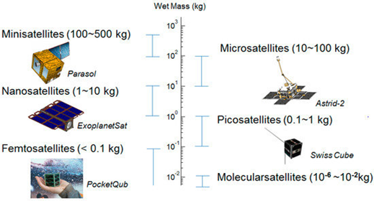Satellite types according to mass: [1]

* Large satellites
* Medium-sized satellites
* Small satellites:
* Minisatellite
* Microsatellite
* Nanosatellite
* Picosatellite
* Femtosatllite

Figure ‎1‑1:Small satellites

Table 1‑1:Classification of satellite according to mass

|  |  |
| --- | --- |
| **Type of satellite** | **Mass range (Kg)** |
| Large satellites | $$≥1000$$ |
| Medium satellites | $$≥500 and <1000$$ |
| Small satellites | $$<500$$ |
| Minisatellite | $$≥100 and <500$$ |
| Microsatellite | $$≥10 and <100$$ |
| Nanosatellite | $$≥1 and <10$$ |
| Picosatellite | $$≥0.1 and <1$$ |
| Femtosatellite | $$≤0.1$$ |

In the expansive field of space exploration, the introduction of nanosatellites has sparked a revolution, reshaping our traditional ideas about how satellites are designed and sent into space.

These small wonders, typically no larger than a common laptop, mark a significant change in the way we approach space missions. Originally starting as experimental projects, nanosatellites have grown to become essential instruments for scientific research, commercial enterprises, and educational purposes. As seen in Figure 1‑2, their use has significantly increased over the years, highlighting their growing importance.

Figure ‎1‑2:Nanosatellite launches with forecasts over years

Nanosatellites, characterized by their compact size and standardized designs, have democratized access to space. This democratization has been particularly pronounced with the introduction of CubeSats. CubeSats, as a subset of nanosatellites, have played a pivotal role in reshaping our approach to space missions.

CubeSats belong to the category of nanosatellites, characterized by a standardized size and form factor. The typical size of a CubeSat is referred to as "one unit" or "1U," measuring 10x10x10 centimeters. However, this size can be expanded to larger configurations, including 1.5U, 2U, 3U, 6U, and even 12U. The concept of CubeSats was originally conceived in 1999 through a collaboration between California Polytechnic State University at San Luis Obispo (Cal Poly) and Stanford University. The primary purpose behind their development was to create an accessible and standardized platform for educational purposes and space exploration, providing an avenue for students and researchers to engage in hands-on experiences in the field of space science.

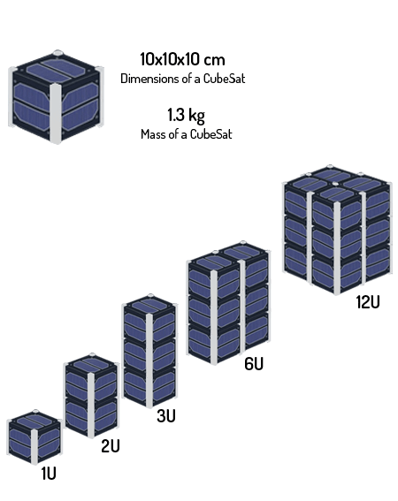

Figure ‎1‑3:Classification of CubeSat according to size

Their modular design allows for flexibility in mission objectives, ranging from Earth observation and scientific research to technology demonstration and educational outreach. The standardization of CubeSats has streamlined the development process, reducing both cost and time.

Within the CubeSat family, the 3U configuration stands out as the most widely utilized. it forms a compact yet potent platform for diverse missions. The widespread adoption of the 3U CubeSat is evident in Figure 1‑4, showcasing its prominence among various nanosatellite types. This specific format adeptly balances size constraints with robust functional capabilities, rendering it an ideal choice for a broad spectrum of applications.

Figure ‎1‑4:Nanosatellite types

# LITERATURE REVIEW

**2**

**CHAPTER**

In the initial stages of our graduation project, we initiated a thorough literature survey as our foundational step. This helped us get a good understanding of what's already out there and served as the foundation for planning our project. We took a close look at the history and technology innovations related to 3U CubeSats, and this information has been guiding us in figuring out how to develop our CubeSat.

The information we gathered from our literature survey acts as our compass, helping us navigate the challenges of designing, making, and launching a CubeSat. With a better understanding of the latest in CubeSat development, we can make smarter decisions and tackle any issues that come up during our project. This intentional approach ensures that our efforts contribute to the ongoing innovation in CubeSat technology.

## General survey

Our survey covering the period from 2003 to October 31, 2023, we aimed to provide a comprehensive snapshot of the nanosatellite landscape. Our analysis began by understanding the importance of CubeSats in this domain. As shown in Figure 2‑1,out of a total of 3891 nanosatellites, including both launched and yet-to-be-launched, a staggering 92.9%, or 3615, are identified as CubeSats. This high percentage underscores the widespread adoption and significance of CubeSats in the realm of nanosatellite technology.

Figure ‎0‑1: Distribution of Nanosatellite Type

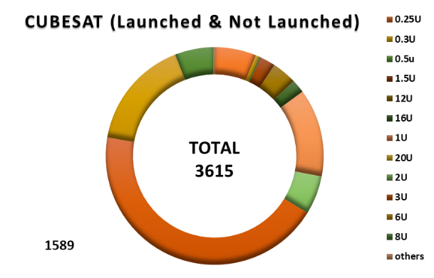Among the CubeSats we identified in our survey, a significant chunk belongs to the 3U category. As shown in Figure 2‑2,out of the total 3615 CubeSats, about 43.95%, which is 1589, are 3U CubeSats. This shows that a good number of these small satellites are in the 3U size. As we dive into our project cantered on creating a 3U CubeSat, these numbers emphasize the importance of this size in the world of small satellites.

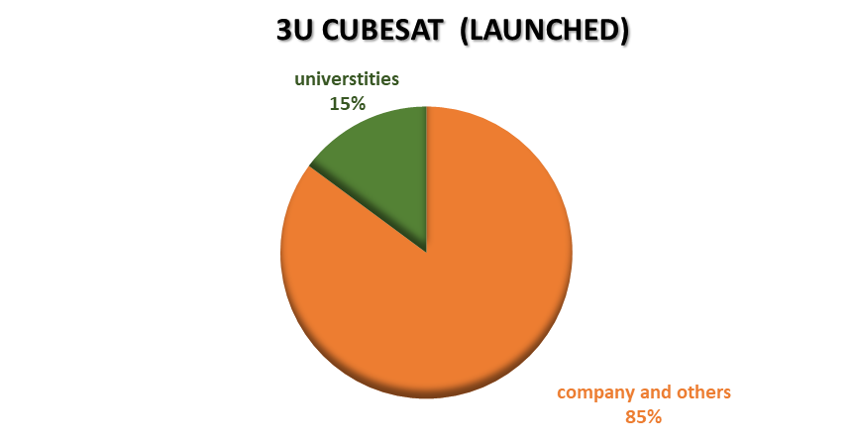As shown in Figure 2‑3, among the launched 3U CubeSats in our survey - totalling 1190- approximately 15%, or around 177, were crafted by universities. This subset holds a particular significance for our research, and we've chosen to focus on these 177 CubeSats made by universities. Our survey will delve into the unique characteristics, innovations, and contributions of these educational institutions to the 3U CubeSat landscape.

Figure ‎0‑2:Distribution of CubeSat Types

Figure ‎0‑3:Distribution of Launched 3U CubeSats

**2.2 University-Developed 3U CubeSats survey**

### 2.2.1 Data collection

For the subset of 177 3U CubeSats crafted by universities, we systematically compiled crucial data encompassing their name, affiliated institution, mission objective, mass, launch vehicle, launch date, status, orbital details, existence of payload, payload type, onboard computer (OBC) type, OBC brand, power consumption and the presence of attitude determination and control systems (ADCS). This comprehensive dataset is meticulously organized into a table inAppendix A, serving as the foundation for our subsequent analysis.

We used Microsoft Excel to create easy-to-understand graphs that showcase trends, patterns, and relationships within the data we collected for the 177 university-developed 3U CubeSats. These graphs are then combined into a user-friendly interactive dashboard shown in Figure ‎2‑19. This approach makes it simple for everyone to explore and analyze our research findings. It not only makes the information easily accessible but also provides a visually appealing platform to interact with the various characteristics of these university-built 3U CubeSats.

### 2.2.2 Data analysis

Next, we transition into the analysis phase where we carefully examine the graphs to extract meaningful insights. These visual representations serve as a crucial tool for understanding the characteristics of university-developed 3U CubeSats. Our objective is to uncover patterns, correlations, and valuable conclusions, contributing to a comprehensive understanding of the landscape. This analytical process will shed light on key aspects, enabling us to identify trends, successful strategies, and potential areas for further exploration within the realm of small satellite development by universities.

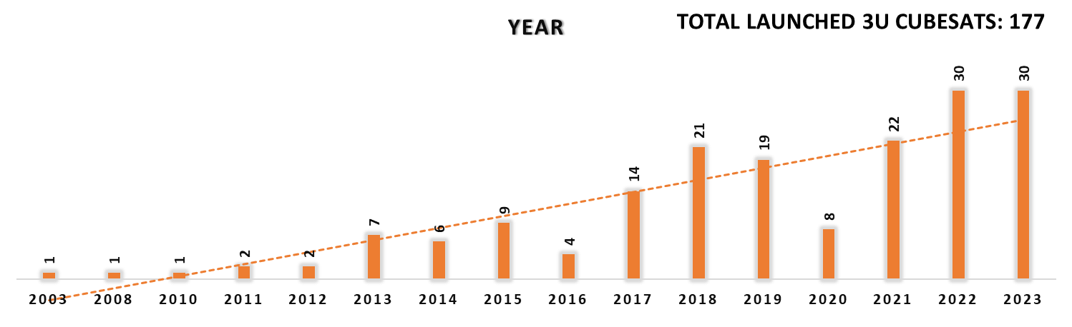**Launch Distribution by Year**

Figure ‎0‑4:Yearly Distribution of 3U CubeSats Manufactured by Universities

Figure 2‑4 shows a consistent increase in 3U CubeSat launches over the years, indicating a growing interest in these small satellites. In 2020, due to the challenges of the COVID-19 pandemic, there was a temporary dip. However, after that, the number of launches picked up again, showing that interest and activity in deploying 3U CubeSats have bounced back.

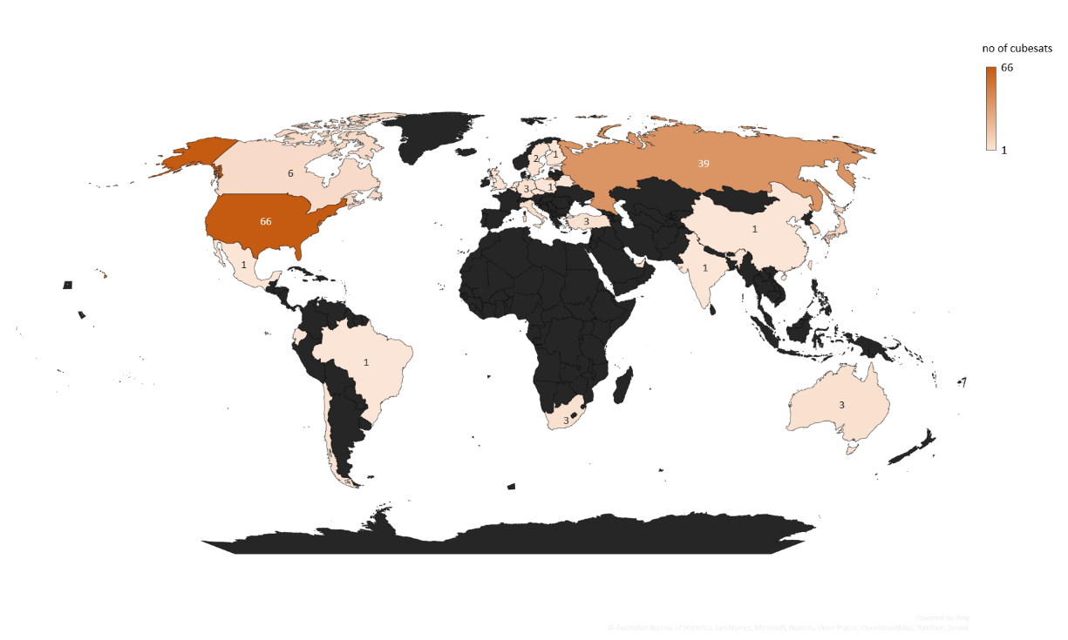**Launch Distribution by Country**

Figure ‎0‑5:Country-wise Distribution of 3U CubeSats Crafted by Universities

Looking at Figure 2‑5, it's clear that the United States takes the lead in launching 3U CubeSats, followed by Russia. This means these two countries are the main players in sending out these small satellites.

**Mission Objective**

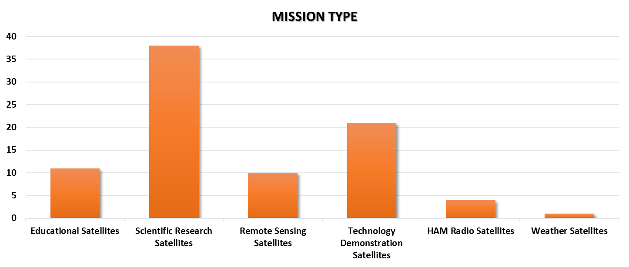

Figure ‎0‑6:Mission-Categorized Analysis of 3U CubeSats Crafted by Universities

Examining Figure 2‑6, it's evident that scientific research stands out as the primary mission objective for launched 3U CubeSats. This indicates a strong emphasis on using these nanosatellites for scientific research and data collection purposes.

For instance, the "[MARIO](https://www.nanosats.eu/sat/mario)" mission represents a scientific 3U CubeSat, equipped with payload for studying special materials called macro-fiber composites (MFC) in space.

Additionally, educational CubeSats, such as "[AuroraSat](https://www.nanosats.eu/sat/aurorasat)", have played a crucial role in engaging students in hands-on satellite projects, The project includes a magnetometer to gather data about the Earth's magnetic field and a MIDI audio feature for interactive outreach. The goal is to engage people in STEM and expand outreach opportunities to include arts and languages, specifically Indigenous languages.

Weather CubeSats, exemplified by the "[TROPICS 7](https://www.nanosats.eu/sat/tropics)" mission, Provide rapid-refresh microwave measurements over the tropics for weather prediction.

Remote sensing missions, illustrated by "[Phoenix"](https://www.nanosats.eu/sat/phoenix-cubesat) , it is equipped with FLIR camera to take thermal images of these cities from space. This helps us understand the Urban Heat Island effect.

Technology demonstration missions are represented by CubeSat like "[PATCOOL](https://www.nanosats.eu/sat/patcool)," which contributed to test special materials in space. It focuses on how the Sun affects these materials by keeping the satellite facing the Sun using a custom system.

**Status Evaluation**

Figure 2‑7 yields valuable insights into the current state of surveyed 3U CubeSats. The fact that around 59 are operational underscores the reliability and effectiveness of these nanosatellites. The successful completion of missions by 54 CubeSats, as indicated by their re-entry, highlights their capability to fulfil objectives. However, the presence of 6 launch failures signals the challenges and risks inherent in deploying these satellites.

**Mass distribution**

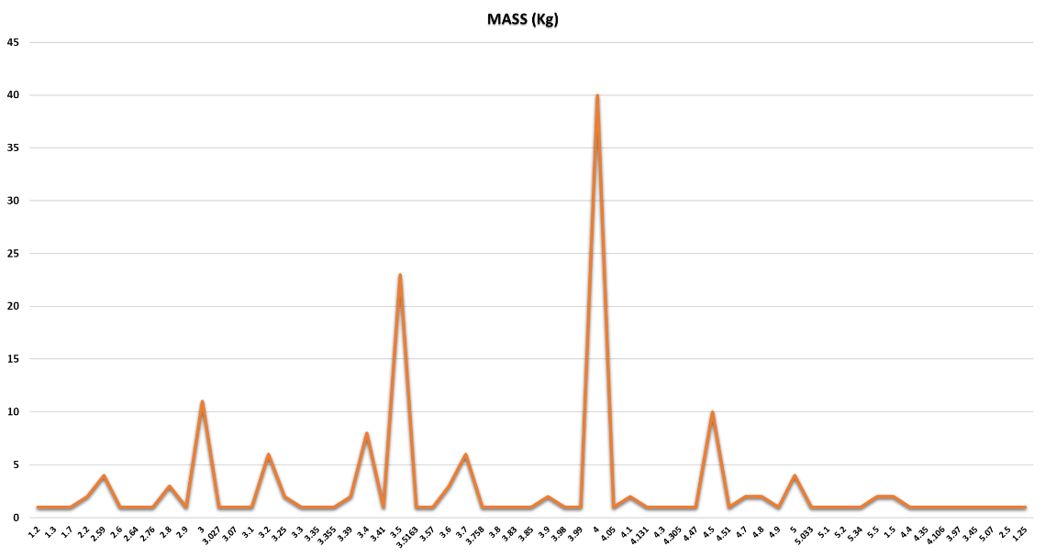

Figure ‎0‑7:Status Distribution

Figure ‎0‑8:CubeSat Design Specification (CDS14)

Figure ‎0‑9:Mass Distribution of 3U CubeSats Crafted by Universities

Examining Figure 2‑8 in correlation with the CubeSat Design Specification (CDS14) [2], Figure 2‑9 shows the typical maximum mass for each U configuration, we can observe that the specified maximum mass for 3U CubeSats is 6kg. Our Mass graph indicates that the actual masses of surveyed 3U CubeSats predominantly fall between 3.5kg and 4kg, with the top end reaching 4kg. The average mass, calculated at approximately 3.693kg, reflects a consistent adherence to the specified limits. This data underscores the compliance of surveyed 3U CubeSats with established standards, showcasing a trend where most satellites align closely with the specified mass range, ensuring conformity with the CubeSat design guidelines.

**Launch Vehicle**

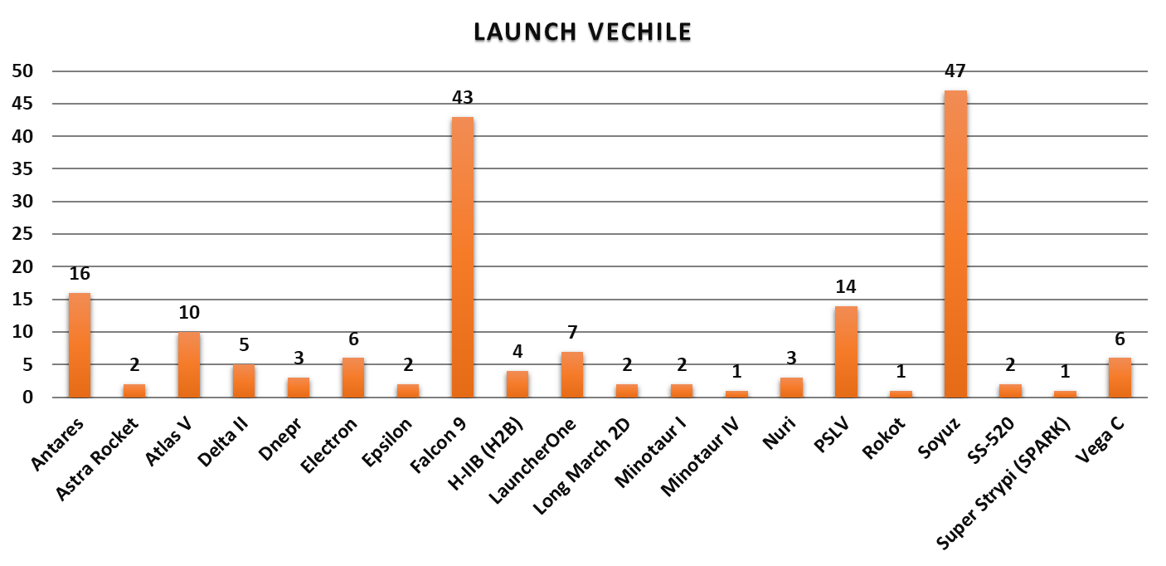

Figure ‎0‑10:3U CubeSats launch providers

Analyzing the Launch Vehicle graph shown in Figure 2‑10 , the data indicates that among the surveyed 3U CubeSats, approximately 43 were launched using Falcon 9, while 47 were launched using the Soyuz vehicle.

The selection of Falcon 9 and Soyuz for launching 3U CubeSats is driven by their reliability, versatility, cost-effectiveness, and widespread availability in the global launch market.

**Orbital Details**

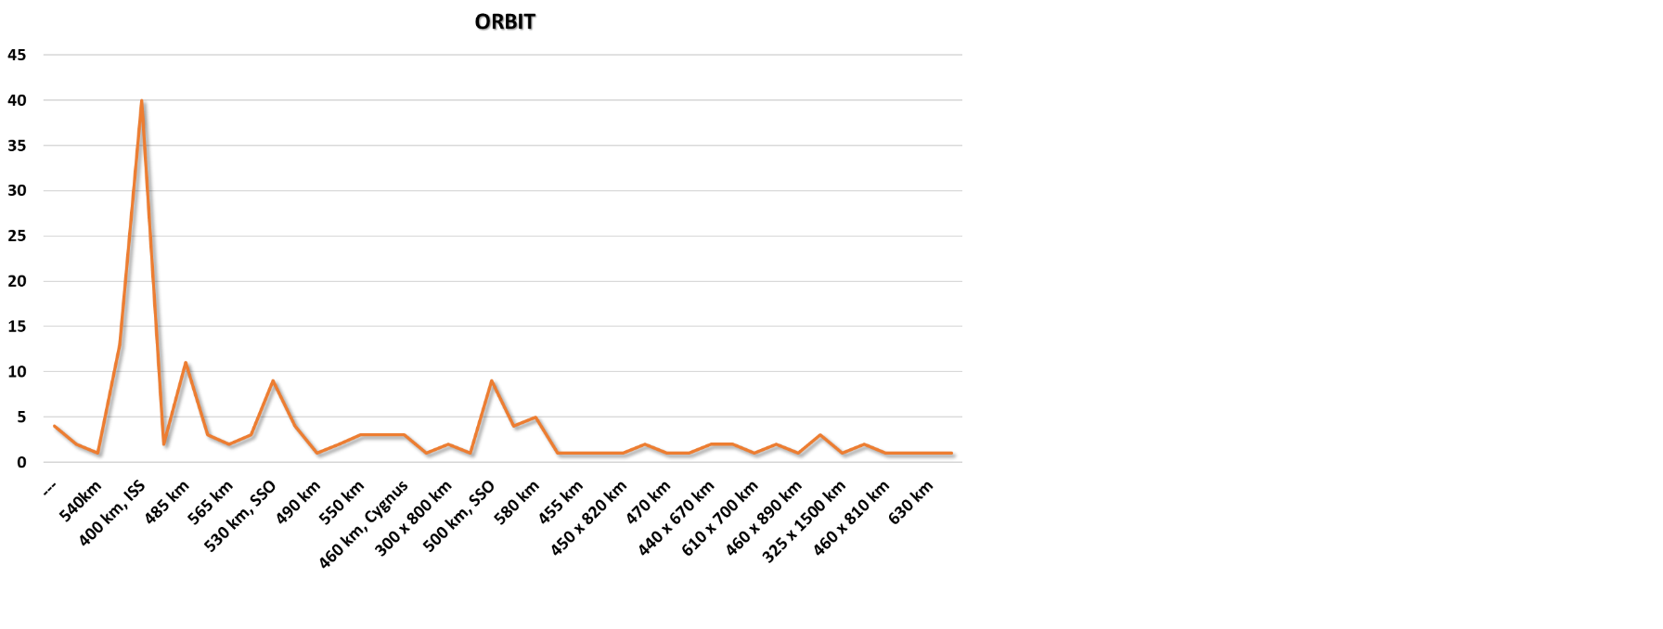

Figure ‎0‑11:Orbit Diversity of 3U CubeSats Crafted by Universities

Figure 2‑11 shows different altitudes for their orbits, ranging from 250 km to 555 km. Notably, the favorite choice among universities is the International Space Station (ISS) orbit at 400 km. This popular preference indicates that universities often choose the ISS orbit for their 3U CubeSat missions, appreciating its strategic position in space.

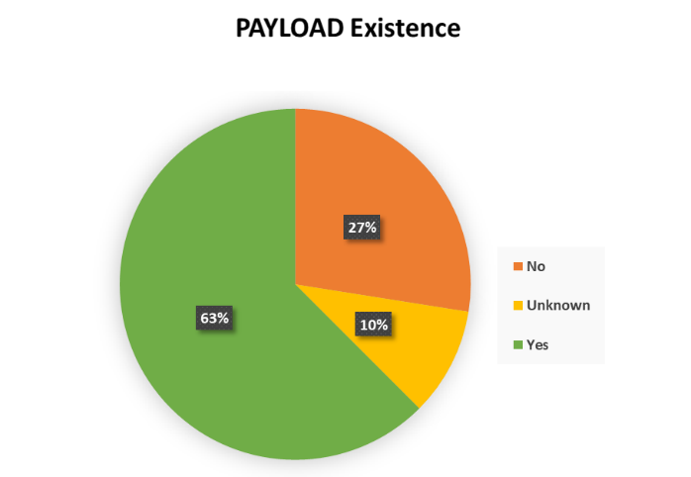**Payload Existence and payload type**

Analyzing Figure ‎2‑12, it is evident that among the surveyed 3U CubeSats, approximately 63% are equipped with payloads, highlighting the prevalent practice of integrating additional instruments or experiments on these small satellites. Conversely, about 27% of the CubeSats do not carry payloads. Notably, for the remaining 10%, information regarding the existence of a payload could not be obtained.

Figure ‎0‑12:Payload Presence in University-Crafted 3U CubeSats

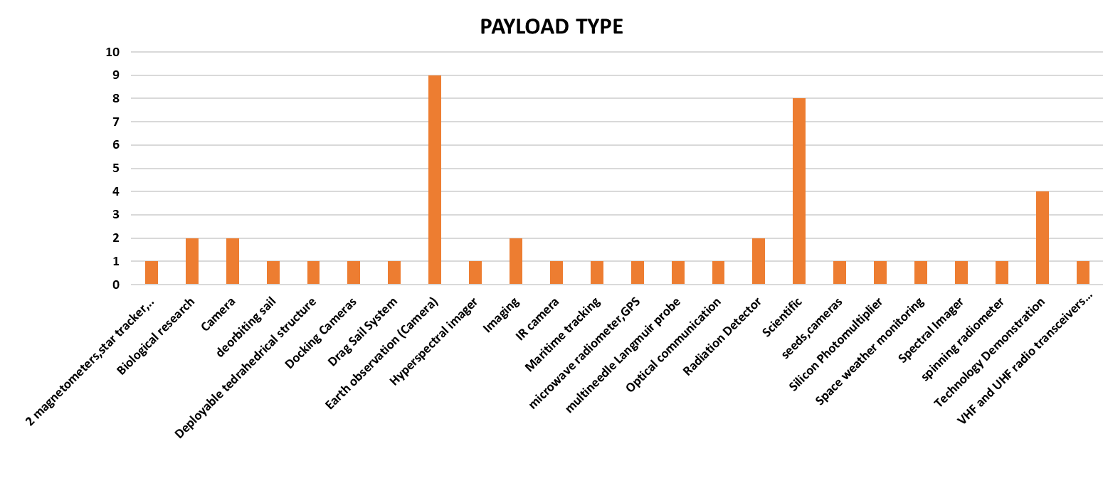

Figure ‎0‑13:Payload Types

Examining Figure ‎2‑13, the predominant payload type among the surveyed 3U CubeSats emerges as cameras designed for Earth observation. This finding underscores the significance of visual data collection for various applications such as environmental monitoring, remote sensing, and geographic analysis.

#### **Onboard Computer (OBC) Type and OBC Name**

Onboard computers are crucial components in CubeSat system, responsible for managing various tasks including processing of commands, handling on-board data, Execution of on-board autonomous functions.

#### 2.2.2.9.1. Single Board Computer (SBC)

An SBC is a full-fledged computer with RAM, storage, input/output, and peripherals like USBs, all on a single motherboard. An SBC also has an OS and can run various programs at the same time.

**Example**: Raspberry Pi, Pumpkin and BeagleBone Black.

#### 2.2.2.9.2. Microcontroller

Microcontrollers and SBCs share processor, storage, and peripherals, but differ significantly in resources and capabilities. Microcontrollers offer limited storage and processing power, often measured in KBs. Microcontrollers also can’t run more than one program at a time, as they are intended to loop one routine.

**Example**: ARM, AVR and PIC.

2.2.2.9.3. Smartphone

Smartphone leverage the powerful processors, sensors, and communication capabilities of modern smartphones to provide cost-effective and versatile solutions for CubeSats.

**Example**: Nexus5.

Analysing Figure ‎2‑14, the data reveals that among the surveyed 3U CubeSats, approximately 83% are equipped with microcontrollers. These microcontrollers serve as compact and efficient computing solutions for managing the satellite's onboard operations. Additionally, around 14% of CubeSats utilize single-board computers, offering a more advanced computing platform for specific missions. Notably, a smaller percentage, approximately 3%, employ smartphones as their onboard computers, showcasing innovative approaches to satellite design.

Figure ‎2‑15 shows a diverse array of onboard computer brands used among the surveyed 3U CubeSats. However, standing out as the most prevalent choices are the MSP430 and ARM.

Figure ‎0‑14:Onboard Computer Types

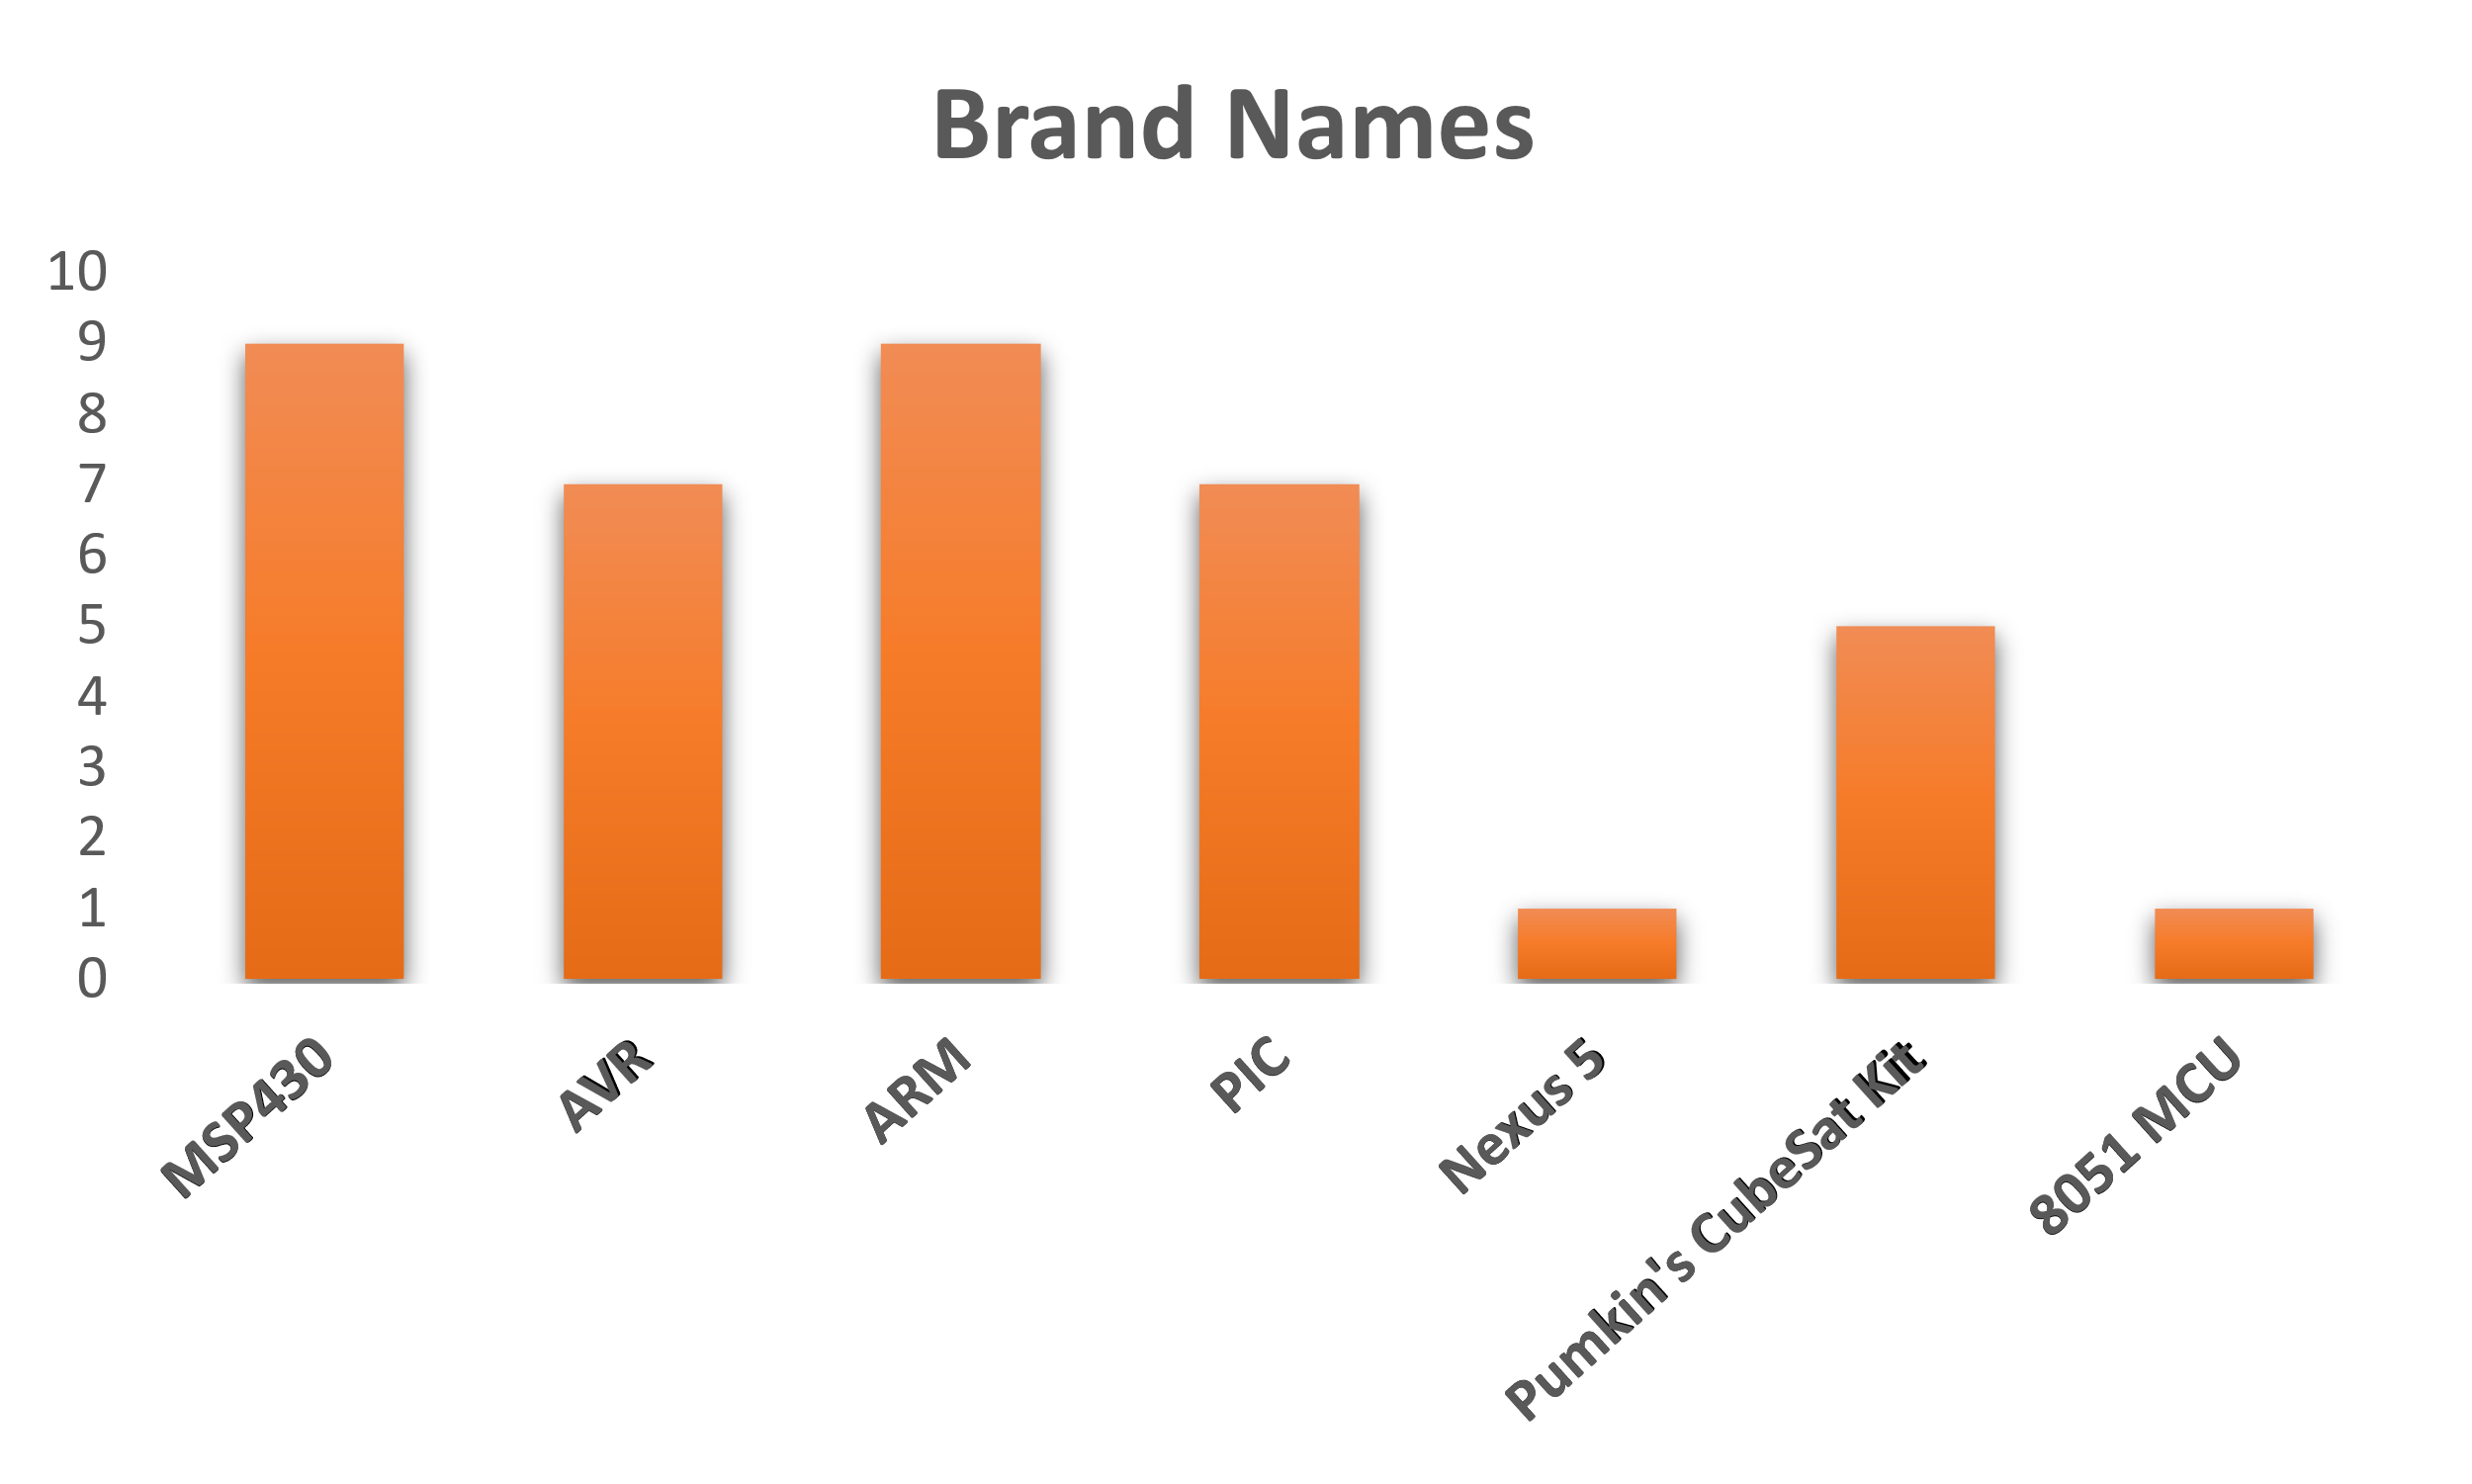

Figure ‎0‑15: OBC Brand Names in University-Crafted 3U CubeSats

#### ADCS Existence

Figure ‎0‑16:ADCS Presence in University-Crafted 3U CubeSats

Analyzing Figure ‎2‑16, it's evident that approximately 78% of the surveyed satellites are equipped with Attitude Determination and Control Systems (ADCS). These systems play a crucial role in stabilizing and orienting the CubeSat in space. On the other hand, about 9% of CubeSats operate without ADCS, relying on alternative methods or having different mission requirements.

Furthermore, for approximately 12% of the surveyed CubeSats, information regarding the presence of ADCS couldn't be obtained. This may indicate challenges in data collection or reporting for these specific satellites.

Additionally, a notable 1% of CubeSats employ Passive Magnetic Attitude Control, showcasing a specialized approach to maintaining orientation through interactions with the Earth's magnetic field.

#### Power Consumption

Figure ‎2‑17 illustrates the distribution of power consumption. Approximately 33% of these CubeSats operate with a minimal power demand, using less than 5 watts. Another 24% fall in the 5 to 10 watts category, indicating a slightly higher power requirement. A significant 33% have power needs ranging from 10 to 20 watts, reflecting diverse mission profiles. Additionally, 10% of the university-developed 3U CubeSats exhibit a substantial power demand, exceeding or equal to 30 watts. This breakdown emphasizes the adaptability of universities in tailoring CubeSats for a range of scientific missions, each with specific power consumption characteristics, contributing to the versatility of these small satellites in scientific research and exploration.

Figure ‎0‑17:Electrical power generation of 3U CubeSat, source: [Design and Implementation of 3U CubeSat Platform Architecture](https://downloads.hindawi.com/journals/ijae/2018/2079219.pdf), [International Journal of Aerospace Engineering](https://www.researchgate.net/journal/International-Journal-of-Aerospace-Engineering-1687-5974?_tp=eyJjb250ZXh0Ijp7ImZpcnN0UGFnZSI6Il9kaXJlY3QiLCJwYWdlIjoicHVibGljYXRpb24ifX0)

In most 3U CubeSats, the solar panels are surface-mounted, and these panels are regulated using MPPT (Maximum Power Point Tracker) to produce the maximum available power. The generated power is stored using secondary battery which is often lithium-ion batteries which became the dominant used batteries in the small satellites in general due to their properties showing in the below table.

Figure ‎0‑18:Battery types used in pico- and nanosatellites until 2010. Reprinted from Acta Astronautical, Vol. 67

*A Review of Battery Technology in CubeSats and Small Satellite Solutions, MDPI*

Table 2‑1:Comparison of the characteristics of different battery types, source: Low Earth Orbit Satellite Design, Springer Publisher

|  |  |  |  |  |
| --- | --- | --- | --- | --- |
| **Battery Types** | **Lead Acid** | **NiCd** | **NiMH** | **Li-Ion** |
| Voltage/Cell | 2.0 | 1.2 | 1.2 | 3.6 |
| Approx. No. of Series Cells for 28V bus | 14 | 24 | 24 | 8 |
| Specific Energy Wh/kg | 30-50 | 45-80 | 60-120 | 150-250 |
| Charge Temperature $℃$ | -20 to +50 | 0 to +45 | 0 to +45 | 0 to +45 |
| Discharge Temperature $℃$ | -20 to +50 | -20 to +65 | -20 to +65 | -20 to +60 |
| Self-Discharge in months | 3-6 | 1-2 | 2-3 | Years |
| Notes | Do Not Discharge to 0 | Ok to Discharge | Ok to Discharge | Cell Protection Needed |
| Approx. Weight of 150 Wh | 3.75kg | 2.5kg | 2.1kg | 0.8kg |

# MISSION ANALYSIS

**3**

**CHAPTER**

# STRUCTURAL SUBSYSTEM

**4**

**CHAPTER**

# ELECTRICAL POWER SUBSYSTEM (EPS)

**5**

**CHAPTER**

# ON BOARD COMPUTER SYSTEM (OBC)

**6**

**CHAPTER**

# COMMUNICATION SUBSYSTEM

**7**

**CHAPTER**

# ATTITUDE DETERMINATION AND CONTROL SUBSYSTEM (ADCS)

**8**

**CHAPTER**

## 8.1. ADCS Overview

Attitude Determination and Control Systems (ADCS) are critical components of spacecraft that ensure the proper orientation (attitude) of the satellite with respect to a desired reference frame. The attitude of a spacecraft is its orientation in space, defined by the rotation angles around its center of mass. ADCS is essential for a wide range of satellite operations, including:

* **Pointing Instruments:** Ensuring that scientific instruments, cameras, or communication antennas are accurately oriented towards their targets (e.g., Earth, other celestial bodies, or deep space).
* **Stabilization:** Maintaining the satellite’s stability to prevent tumbling and ensure smooth operation of onboard systems.
* **Maneuvering:** Adjusting the satellite's orientation for orbital adjustments, docking procedures, or avoiding space debris.

### 8.1.1. Importance and Applications of ADCS

ADCS plays a pivotal role in various satellite missions, including:

1. **Earth Observation:** Satellites equipped with imaging sensors require precise pointing accuracy to capture high-resolution images of the Earth's surface. ADCS ensures that the sensors are oriented correctly to achieve the desired coverage and resolution.
2. **Communication Satellites:** These satellites need to maintain a fixed orientation relative to the Earth to ensure continuous and stable communication links. ADCS helps in keeping the communication antennas pointed towards ground stations or other satellites.
3. **Scientific Research:** Space missions conducting experiments or observations in space rely on ADCS to point telescopes or other instruments accurately at celestial objects or specific regions of interest.
4. **Navigation and GPS:** Satellites in global positioning systems (GPS) need precise attitude control to provide accurate location data. ADCS helps in maintaining the required orientation for signal transmission and reception.
5. **Interplanetary Missions:** Spacecraft traveling to other planets or celestial bodies need ADCS to orient their instruments for scientific observations, navigation, and communication with Earth.

### 8.1.2. Different Types of Attitude Control Systems

There are various types of attitude control systems, broadly categorized into passive and active systems. Each system has its advantages and is chosen based on the mission requirements and constraints.

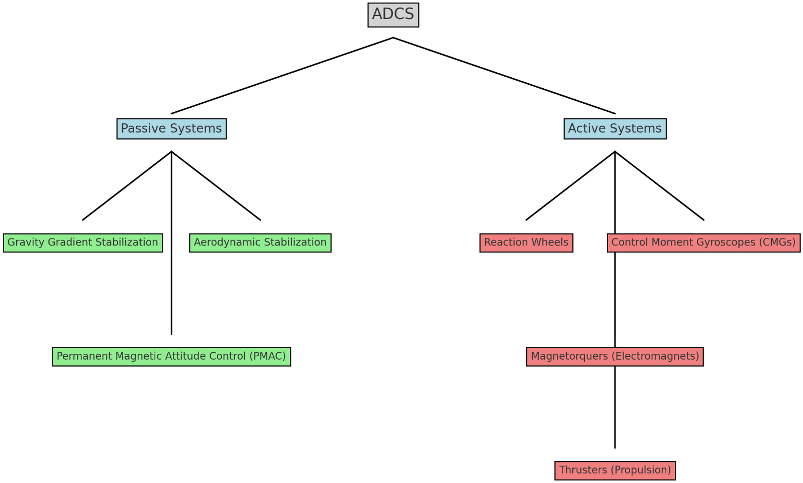

**1. Passive Attitude Control Systems:** Passive systems rely on natural forces and do not require active components or power for attitude control. These systems are simpler, cost-effective, and often used in small satellites with limited power and budget.

* **Gravity Gradient Stabilization:** Utilizes the gravitational gradient force to align the satellite’s long axis with the local vertical. It is suitable for low Earth orbit (LEO) satellites.
* **Aerodynamic Stabilization:** Uses the atmospheric drag to align the satellite’s aerodynamic surfaces along the velocity vector. This method is effective in LEO where atmospheric drag is significant.
* **Magnetic Attitude Control:** Utilizes the Earth’s magnetic field to align the satellite. Passive Magnetic Attitude Control (PMAC) systems use permanent magnets or magnetically soft materials to create a stabilizing torque.

**2. Active Attitude Control Systems:** Active systems employ actuators and sensors to actively control the satellite’s orientation. These systems offer higher accuracy and flexibility but require power and more complex components.

* **Reaction Wheels:** Small, spinning wheels that change the satellite’s orientation by conserving angular momentum. They provide precise control but can be prone to saturation and require desaturation mechanisms.
* **Control Moment Gyroscopes (CMGs):** Similar to reaction wheels but provide greater torque by changing the orientation of the spinning wheels. CMGs are used in larger satellites requiring rapid and significant attitude adjustments.
* **Magnetorquers:** Electromagnets that interact with the Earth’s magnetic field to generate torques for attitude control. They are effective in LEO and can complement other attitude control methods.
* **Thrusters:** Small propulsion devices that exert forces on the satellite to change its orientation. They are used in larger satellites or interplanetary missions where high precision and flexibility are required.

## 8.2. Selection of Permanent Magnet Attitude Control System

For the mission at hand, we have chosen the Permanent Magnet Attitude Control (PMAC) system due to its several advantages:

* **Zero Power Consumption:** PMAC systems do not require any power for their operation, making them ideal for small satellites like CubeSats with limited power budgets.
* **Low Mass:** The system adds less than 50 grams of mass to the satellite, which is crucial for small satellites where every gram counts.
* **Simplicity and Reliability:** PMAC systems are simpler in design compared to active systems, reducing the potential points of failure and increasing reliability.
* **Alignment with Earth's Magnetic Field:** PMAC can align the CubeSat within ±10° of the Earth's magnetic field, providing sufficient pointing accuracy for many missions without the need for complex control algorithms or active components.

### 8.2.1. Satellite Orientation Across the Orbit

Our CubeSat uses a Passive Magnetic Attitude Control (PMAC) system that aligns the CubeSat to the Earth’s local magnetic field line at all points in the orbit. The system is composed of two primary elements. The first is a bar magnet, which provides a restoring torque towards the local magnetic field of the Earth. The second is an array of soft-magnetic hysteresis rods mounted orthogonal to the bar magnet, which are magnetized by the local Earth field. As the satellite rotates, the relative orientation between the hysteresis rods and the local Earth magnetic field changes, which changes the polarity of the rods. Energy is lost to heat as the magnetic domains within the hysteresis rods change direction. This energy loss serves to dampen the satellite rotation until the satellite bar magnet axis is roughly aligned with the local Earth field direction. Thus, the satellite will settle to track the local magnetic field at each point in its orbit.

## 8.3. Magnetic Field Inclination

Figure 23 Magnetic field inclination at Egypt IGFR-13 Model

Figure 24 Magnetic Field Inclination through the Orbit

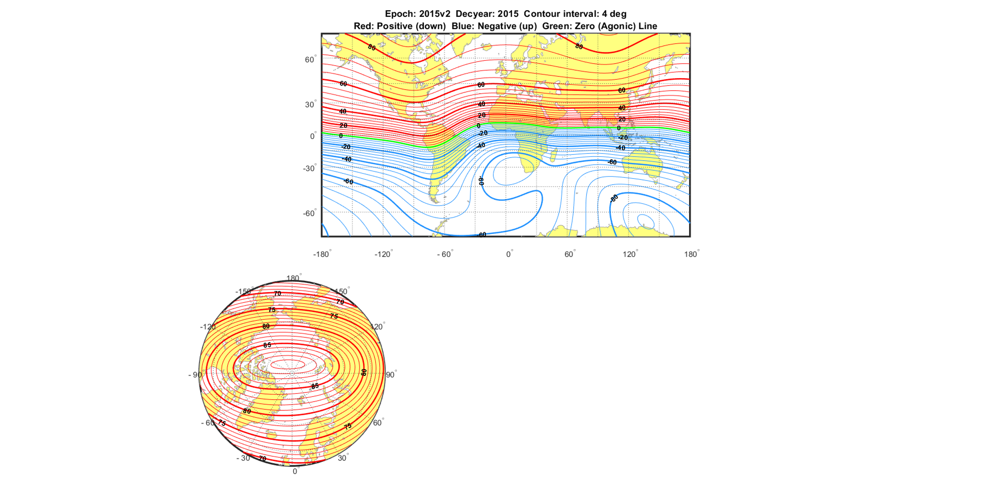

Figure 25 Magnetic Field Inclination at Egypt WMM Model

Antenna direction

**40o**

Egypt

The decision to adopt a parallel configuration for the satellite over Egypt was driven by the region's magnetic field inclination of 39.5 degrees. This configuration ensures that the permanent magnet aligns parallel to the direction of the monopole antenna, optimizing the satellite's orientation for effective communication across designated areas. By aligning the magnet parallel to the antenna direction, the Permanent Magnet Attitude Control (PMAC) system enhances predictability and stability during orbit. This choice simplifies the alignment process, crucial for achieving reliable communication and maintaining operational efficiency throughout the mission. The strategic placement of the magnet, integral to the PMAC system design, was carefully coordinated to align with the satellite's roll axis and the antenna's orientation, reinforcing the effectiveness of the parallel configuration in meeting mission objectives.

## A transparent plastic box with red and blue tape Description automatically generated with medium confidence8.4. PMAC Configuration

to achieve nadir pointing in the Northern Hemisphere, the permanent magnet should be aligned in the Z-direction with the North pole facing the –Z direction. This configuration ensures that the CubeSat aligns its axis with the Earth's magnetic field, achieving the desired orientation. Additionally, the hysteresis rods should be strategically placed to enhance the stabilization and damping effects. Specifically, four hysteresis rods should be positioned in pairs two along the X-axis and two along the Y-axis. This arrangement optimizes the interaction between the rods and the Earth's magnetic field, ensuring effective damping and stabilization. It is crucial to maintain a proper distance between the rods and the magnet to ensure optimal performance. The distance between the rods and the magnet should not exceed 6.5 cm. This spacing ensures that the magnetic fields interact effectively without compromising the structural integrity and functionality of the CubeSat.

## 8.5. Environment and Disturbances

Disturbances acting upon a satellite can be categorized into external and internal disturbances. External effects are those originating from the space environment, which are the focus of this section. These effects would act even if the spacecraft were a rigid body. Internal disturbances are closely tied to the spacecraft's structure, including internal moving parts and mass or radiation being emitted. A critical step in tailoring the rigid body equations of motion for a specific application is to develop a thorough understanding of the torques that appear in these equations. Significant environmental torques affecting satellite attitude dynamics include gravity gradient, magnetic, aerodynamic, and solar radiation pressure torques.

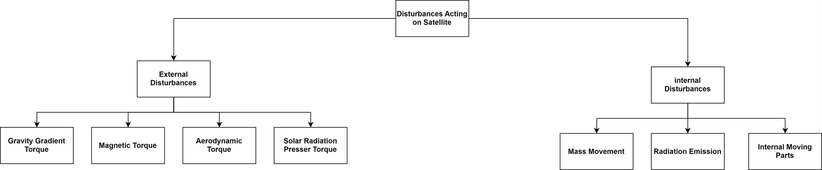

### 8.5.1. Gravity Gradient Torque

Gravity Gradient Torque is an important consideration for satellite attitude control, especially when the satellite has an asymmetrical mass distribution. The torque arises due to the difference in gravitational force experienced by different parts of the satellite.

For a rigid body in space, the gravitational force on the "lower" parts of the body (closer to the Earth) will be stronger than on the "upper" parts (farther from the Earth). This difference in force creates a torque around the satellite's center of mass. This torque can be particularly useful for passive stabilization, causing the satellite to align with its long axis pointing towards the nadir (the point on the Earth directly below the satellite).

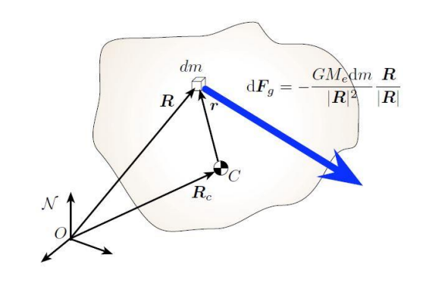

Figure 26 Inertial Frame: N and Body Frame: B

The Gravity gradient torque acting on the spacecraft is:

$$L_{G}=\int_{B}{ }r×dF_{G}$$

The gravity force acting on the mass element is:

$$dF_{G}=-\frac{GM_{e}}{|R|^{3}}Rdm$$

The gravity gradient torque is then written as:

$$L_{G}=-\int_{B}{ }r×\frac{GM_{e}}{|R|^{3}}\left(R_{c}+r\right)dm$$

Taking all the constants outside of the integral term, we find:

$$L_{G}=GM_{e}R_{c}×\int_{B}{ }\frac{r}{|R|^{3}} dm$$

Where,

$$\begin{matrix}|R|^{-3}={\left|R_{c}+r\right|}^{-3} & ={\left(R_{c}^{2}+2R_{c}⋅r+r^{2}\right)}^{-3/2} \\ {\left|R\right|}^{-3} & =\frac{1}{R_{c}^{3}}{\left(1+\frac{2R_{c}⋅r}{R_{c}^{2}}+{\left(\frac{r}{R_{c}}\right)}^{2}\right)}^{-3/2} \\ {\left|R\right|}^{-3} & ≈\frac{1}{R_{c}^{3}}\left(1-\frac{3R_{c}⋅r}{R_{c}^{2}}+⋯\right)\end{matrix}$$

Then,

$$L_{G}=\frac{GM_{e}}{R_{c}^{3}}R_{c}×\int_{B}{ }r\left(1-\frac{3R_{c}⋅r}{R_{c}^{2}}\right)dm$$

Using the center of mass definition:

$$\int_{B}{ }r dm=0$$

the gravity gradient torque is reduced to:

$$L_{G}=\frac{3GM_{e}}{R_{c}^{5}}R_{c}×\int_{B}{ }-r\left(r⋅R_{c}\right)dm$$

and

$$-\left(r⋅R_{c}\right)r=-r×\left(r×R_{c}\right)-(r⋅r)R_{c}$$

Then,

$$L_{G}=\frac{3GM_{e}}{R_{c}^{5}}R_{c}×\int_{B}{ }-\left(r×\left(r×R_{c}\right)+(r⋅r)R_{c}\right)dm$$

the gravity torque on a rigid body is finally written as

$$L_{G}=\frac{3GM_{e}}{R_{c}^{5}}R_{c}×[I]R_{c}$$

### 8.5.2. Magnetic Disturbance Torque

Magnetic disturbance torque arises when a spacecraft with a non-zero net magnetic moment $\left(\vec{m}\right)$ interacts with the Earth's magnetic field $\left(\vec{B} \right) .$ The torque $\left(\vec{T_{m}}\right)$ is given by the cross product of the spacecraft's magnetic moment and the magnetic flux density of the external magnetic field:

$$\vec{T_{m}}=\vec{m} x \vec{B}$$

The Earth’s magnetic field can be approximated by a dipole field, where the magnetic flux density $\vec{B}$ at a point in space is a function of the position relative to the Earth's magnetic dipole. The Earth's magnetic field varies with location and altitude but can be approximated in a local region by models such as the International Geomagnetic Reference Field (IGRF).

#### 8.5.2.1. Sources of Magnetic Dipole Moment in Spacecraft

1. **Eddy Currents**
   * **Description**: Eddy currents are electrical currents induced in the conducting parts of the satellite as it moves through the Earth's magnetic field.
   * **Effect**: These currents generate their own magnetic fields, which oppose the motion of the satellite, resulting in a damping torque.
   * **Purpose**: Acts as a momentum damping factor, helping to stabilize the satellite's attitude.
2. **Magnetic Hysteresis Torque**
   * **Description**: Magnetic hysteresis torque is generated when high-hysteresis materials within the satellite magnetize and demagnetize periodically due to the changing magnetic flux.
   * **Effect**: This hysteresis dissipates kinetic energy.
   * **Purpose**: Used for passive momentum damping. Hysteresis rods, made of materials with significant hysteresis properties, are often used to detumble the spacecraft and provide passive stabilization.
3. **Magnetic Actuators (Magnetorquers)**
   * **Description**: Magnetic actuators, also known as magnetorquers, are devices that generate a controllable magnetic moment by passing an electric current through coils.
   * **Effect**: These actuators interact with the Earth's magnetic field to produce torque.
   * **Purpose**: Enable three-axis attitude stabilization by altering the satellite's net magnetic moment in real-time.
4. **Permanent Magnets** 
   * **Description**: Permanent magnets used in Permanent Magnet Attitude Control (PMAC) systems provide a constant magnetic dipole moment.
   * **Effect**: The constant magnetic field interacts with the Earth's magnetic field, generating a restoring torque on the satellite.
   * **Purpose**: Used in CubeSats and other small satellites for passive attitude stabilization or in combination with other control systems for enhanced control.

### 8.5.3. Solar Radiation Torque

In the design of spacecraft attitude-control systems, various torques that disturb the spacecraft's attitude must be considered. One of the significant torques is due to radiation forces on the spacecraft surfaces. Radiation incident on a spacecraft’s surface generates forces that may cause a torque about the spacecraft’s mass center.

#### 8.5.3.1. Sources and Factors Influencing Radiation Torque

1. **Direct Solar Photon Radiation**
   * The most significant source of radiation torque is direct solar photon radiation.
   * Solar photons impart momentum when they strike the spacecraft's surface, causing a force that can create torque.
2. **Earth-Reflected Sunlight and Infrared Emission**
   * Sunlight reflected from the Earth and infrared radiation emitted by the Earth and its atmosphere also contribute to radiation forces.
   * These forces are generally smaller than those from direct solar radiation but must still be considered.
3. **Asymmetrical Emission of Electromagnetic Energy from the Spacecraft**
   * This includes heat or radio signals emitted from the spacecraft's surfaces.
   * Such emissions can create torques due to the asymmetrical distribution of radiation.

#### 8.5.3.1. Major Factors Determining Radiation Torques

1. **Intensity, Spectrum, and Direction of Incident or Emitted Radiation**
   * The intensity and spectrum of the radiation impact the magnitude of the force.
   * The direction of the incident radiation relative to the spacecraft's orientation is crucial in determining the resulting torque.
2. **Shape and Surface Characteristics of the Spacecraft**
   * The shape of the spacecraft and the location of the surface relative to the spacecraft's mass center affect how the radiation forces create torques.
   * The optical properties of the surface, such as reflectivity and emissivity, also play a significant role.
3. **Altitude of the Spacecraft**
   * At altitudes above 1000 km, aerodynamic forces diminish, making radiation torques more significant.
   * The effect of radiation forces is nearly constant in near-Earth orbits.

The most important cause of radiation torques is direct solar photon radiation. The forces caused by the other sources are usually at least an order of magnitude smaller. In force calculations, the intensity of solar corpuscular radiation (the solar wind) is usually negligible.

The power radiated from an element of area on the spacecraft is:

$$E=σϵT^{4}$$

where $E=$ 
 emissive power in $W/m^{2}$ $ϵ=$ 
 nondirectional emissivity, dimensionless $σ=$ 
 Stefan-Boltzmann constant $=5.67×{10}^{-8} W/m^{2}{\left( ^{∘}K\right)}^{4}$ $T=$ 
 surface temperature in degrees Kelvin

#### 8.5.3.2. Radiation Forces

When radiant energy is incident on a surface, it exerts a force per unit area, known as surface stress, which is equal to the vector difference between the impinging and reflected momentum flux.

**General Formulation**

The general differential radiation force on an elemental area $dA$ can be expressed as:

$$dF_{r}=\frac{I}{c}\left[-\left(cos⁡θ+\frac{2}{3}c_{rd}n+sin⁡θs\right)\right]cos⁡θdA$$

where:

* $I=$ energy per unit time through a cross-sectional unit area, in $N/m^{2}$
* $c=$ speed of light, in $m/s$
* $c_{a}=$ absorption coefficient (fraction of incident radiation absorbed)
* $c_{rs}=$ coefficient of specular reflection (fraction of incident radiation specularly reflected)
* $c_{rd}=$ coefficient of diffuse reflection (fraction of incident radiation diffusely reflected)
* $θ=$ angle of incidence
* $n$ and $s$ are unit vectors normal and tangential to the surface, respectively

The coefficients must satisfy:

$$0≤c_{a}+c_{rs}+c_{rd}≤1$$

Special Cases

1. Completely Absorbing Surface ( )

Figure 27 Absorption

1. Completely Specularly Reflecting Surface ( )

Figure 28 Specular Reflection

1. Completely Diffusely Reflecting Surface )

Figure 29 Diffuse Reflection

#### 8.5.3.2.Radiation Torque

The radiation torque $L_{r}$ on a spacecraft is calculated from the vector cross product of the position vector 1 (from the spacecraft's mass center to the elemental area $dA$) and the radiation force $dF$ acting on that area. The general expression for the radiation torque is given by:

$$L_{r}=\int_{\text{surface }}{ }1×dF$$

Radiation Force $dF$  
The radiation force dF on an elemental area $dA$ can be expressed as:

$$dF=\frac{I}{c}cos⁡θ\left[-\left(\left(1+c_{rs}\right)cos⁡θ+\frac{2}{3}c_{rd}\right)n+\left(1-c_{rs}\right)sin⁡θs\right]dA$$

where:

* $I=$ energy per unit time through a cross-sectional unit area, in $N/m^{2}$
* $c=$ speed of light, in $m/s$
* $c_{a}=$ absorption coefficient
* $c_{rs}=$ coefficient of specular reflection
* $c_{rd}=$ coefficient of diffuse reflection
* $θ=$ angle of incidence
* $n=$ unit vector normal to the surface
* $s=$ unit vector tangential to the surface

Integration Over the Surface  
To find the total radiation torque, the radiation force must be integrated over the entire exposed surface of the spacecraft. This can be done by summing the contributions from each elemental area:

$$L_{r}=\sum_{i}{ }l_{i}^{'}×F_{i}$$

### 8.5.4. Aerodynamics Disturbance

Aerodynamic disturbance torque is caused by the interaction between atmospheric gas molecules and the surfaces of a spacecraft. To determine the aerodynamic torque, the following factors must be considered:

1. **Atmospheric Characteristics**: Understanding the density, composition, and motion of the atmosphere due to Earth's rotation.
2. **Spacecraft Characteristics**: Knowing the aerodynamic properties and mass distribution of the spacecraft.
3. **Interaction with Atmosphere**: Assessing how the spacecraft interacts with the atmosphere and its relative velocity with respect to the atmosphere.

#### 8.5.4.1. Aerodynamic Torque Calculation

Aerodynamic torques decrease significantly with increasing orbital altitude. For Earth-orbiting spacecraft, aerodynamic forces are more influential below 600 km, while radiation forces become more significant above 1000 km. In the 600-1000 km range, both forces may be comparable. However, aerodynamic forces primarily determine the orbital lifetime of a spacecraft.

#### **Total Aerodynamic Force**

The aerodynamic force $F$ on a spacecraft can be calculated using the following equation:

$$F=\frac{1}{2}C_{D}ρV^{2}A$$

where:

* $F=$ total aerodynamic force ( N )
* $ρ=$ atmospheric density $\left(kg/m^{3}\right)$
* $A=$ projected area of the spacecraft element normal to the incident flow $\left(m^{2}\right.$)
* $V=$ relative velocity of the spacecraft with respect to the atmosphere $(m/s)$
* $C_{D}=$ drag coefficient (typically assumed to be 2.6 for a conservative estimate)

Aerodynamic Torque  
The aerodynamic torque $L_{a}$ is given by:

$$L_{a}=lF$$

where:

* $L_{a}$ ​ = total aerodynamic torque ($N·m$)
* $l$ = moment arm (distance from the center of mass to the point of force application) (m)

## 8.6. Coordinate Systems

Defining a suitable reference system is crucial for accurately describing an orbit. A reference system consists of a set of prescriptions and conventions, along with the necessary modeling requirements, to define a triad of axes at any given time. This system is different from a frame, which is the practical realization of a coordinate set within the broader context of the system. A reference frame, therefore, is composed of three orthonormal unit vectors that establish a right-handed coordinate system.

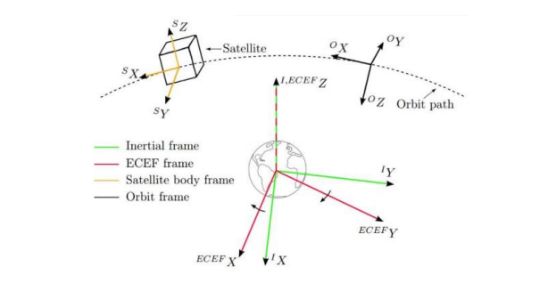

Figure 30 Different coordinate systems of The Earth and Satellite

### 8.6.1. Preliminary Concepts Before Defining Coordinate Systems

Before defining our coordinate systems, it's essential to understand a few key concepts:

#### 8.6.1.1. Celestial Sphere

The celestial sphere is a useful construct for describing the positions of objects in the sky. It is a fictitious sphere centered on the Earth, upon which all celestial bodies are projected. The poles and equatorial plane of this sphere coincide with those of the Earth. We can specify the precise locations of objects on the celestial sphere using celestial equivalents of longitudes (meridians) and latitudes (parallels).

The projection of the Earth's equator onto the celestial sphere is called the celestial equator. Similarly, the Earth's system of longitude and latitude can be projected onto the celestial sphere, giving rise to celestial coordinates: right ascension and declination.

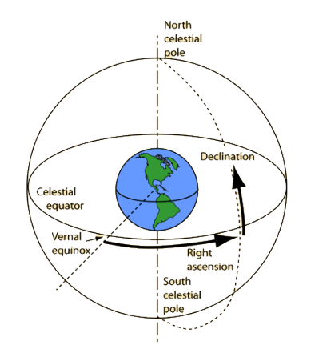

Figure 31Geometry of the Celestial Sphere

#### 8.6.1.2.Ecliptic Plane

From the Earth's reference frame, the Sun appears to move around the Earth along a path tilted with respect to the spin axis by 23.5°. This path is known as the ecliptic. The 23.5° tilt of the Earth's spin axis relative to its solar orbit plane causes the seasonal variations in the amount of sunlight received at the surface.

The angle between the Earth's mean equator and the ecliptic is called the obliquity of the ecliptic. This angle is approximately 23.5°, although it varies slightly over time due to perturbations. The points where the ecliptic intersects the equatorial plane of the celestial sphere are called equinoxes. There are two equinoxes: the vernal equinox around March 21, when the Sun is at the ascending node, and the autumnal equinox around September 23, when the Sun is at the descending node.

#### 8.6.1.3.Vernal Equinox

The vernal equinox occurs when the Sun's declination is 0°, transitioning from negative to positive values. This point is slightly different from the intersection of the ecliptic and the equator because the ecliptic represents the mean path of the Sun, not its true (or actual) path. In other words, the vernal equinox occurs at the ascending node of the Sun as observed from Earth.

#### 8.6.1.4.Hour Angle

The hour angle is one of the coordinates used in the equatorial coordinate system to determine the position of a point on the celestial sphere. It measures the angular distance along the celestial equator of an object, similar to longitude. The hour circle passing through the observer is 0 hours, known as the primary hour circle. The hour angle of any object is the angle from the primary hour circle to the hour circle of the object, typically measured in hours from 0 to 24.

The current hour angle of any object is the elapsed time since the object was overhead. This definition applies to all objects (Sun, stars, and satellites) for local observers (the Local Hour Angle, LHA) and observers at Greenwich (the Greenwich Hour Angle, GHA).

$$LHA=GHA+λ$$

### 8.6.2. Earth-Based Systems

#### 8.6.2.1. Earth-Centered Inertial (ECI)

The Earth-Centered Inertial (ECI) coordinate system is used for attitude applications and is also known as the celestial coordinate system. Its frames originate at the Earth's center of mass and do not rotate. The X-axis is aligned with the vernal equinox, the Z-axis points towards the North Pole and is defined as the Earth's rotation axis, and the Y-axis completes the triad to form a right-handed coordinate system, lying on the equatorial plane.

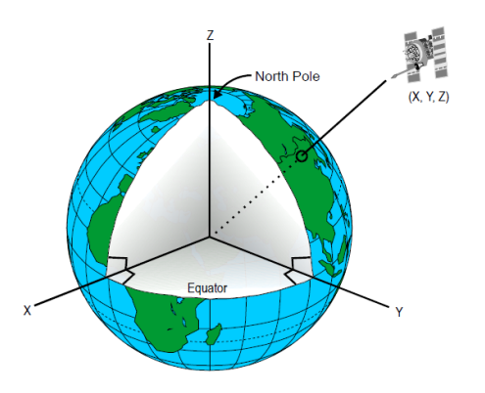

Figure 32 Inertial Coordinate System

#### 8.6.2.2. Earth-Centered, Earth-Fixed (ECEF or Greenwich System)

The Earth-Centered, Earth-Fixed (ECEF) coordinate system is fixed to the Earth and rotates with it. Its origin is located at the Earth's center of mass. The X-axis intersects the Earth's surface at 0° latitude (the equator) and 0° longitude (the prime meridian in Greenwich).

In the ECEF system, the coordinates of a point fixed on the Earth's surface do not change over time because the system rotates with the Earth. This makes it ideal for applications where a stable, Earth-fixed reference is needed.

Figure 33 Greenwich Coordinate System

### 8.6.3. Transformation between Earth based systems

Transformation from ECI to ECEF The rotation of the Earth-Centered, Earth-Fixed (ECEF) frame relative to the Earth-Centered Inertial (ECI) frame involves a rotation about the coincident z-axis of both frames by an angle α, which corresponds to the Sidereal Time $(θ_{GMST}) .$ This rotation can be represented by the rotation matrix:

$$R_{F}^{I}=\left[\begin{matrix}cos⁡α & sin⁡α & 0 \\ -sin⁡α & cos⁡α & 0 \\ 0 & 0 & 1\end{matrix}\right]$$

Where: $α$ is the Sidereal Time $\left(θ_{GMST}\right)$ Any vector can be transformed from ECI to ECEF by multiplying it to the rotation matrix as follows:

$${\text{ Vector }}_{F}=R_{F}^{I}*{ \text{V}\text{ector }}^{I}$$

And we can do the inverse relation to transform from ECEF to ECI as follows:

$${\text{ Vector }}_{I}={\left[R_{F}^{I}\right]}^{-1}*{\text{ Vector }}^{F}$$

### 8.6.4. Satellite-Based Systems

#### 8.6.4.1. Orbit Frame

The orbital coordinate system moves with the satellite and is defined as follows:

* **Origin:** Located at the satellite's center of mass.
* **Z-axis:** Points towards the Earth's center of mass, perpendicular to the xy-plane.
* **X-axis:** Points in the direction of the satellite's flight.
* **Y-axis:** Perpendicular to the x-axis, pointing in the direction of the orbit velocity vector.

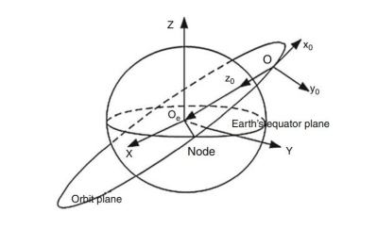

Figure 34 The orbital coordinate system

#### 8.6.4.2.Satellite Body Frame

The satellite body frame is fixed to the satellite's body and is defined as follows:

* **Origin:** At the satellite's center of mass.
* **X-axis:** Points in the direction of the satellite's flight.
* **Z-axis:** Points up through the top of the satellite's body.
* **Y-axis:** Perpendicular to the xz-plane, satisfying the right-hand rule.

Figure 35 The Body coordinate system

### 8.6.5. Transformation Between Satellite Based Systems

#### 8.6.5.1. Transformation from Orbit to Body frame

$$R_{\text{Orbit }→\text{ Body }}=\left[\begin{matrix}q_{0}^{2}-q_{1}^{2}-q_{2}^{2}+q_{3}^{2} & 2\left(q_{0}q_{1}+q_{2}q_{3}\right) & 2\left(q_{0}q_{2}-q_{1}q_{3}\right) \\ 2\left(q_{0}q_{1}-q_{2}q_{3}\right) & -q_{0}^{2}+q_{1}^{2}-q_{2}^{2}+q_{3}^{2} & 2\left(q_{1}q_{2}+q_{0}q_{3}\right) \\ 2\left(q_{0}q_{2}+q_{1}q_{3}\right) & 2\left(q_{1}q_{2}-q_{0}q_{3}\right) & -q_{0}^{2}-q_{1}^{2}+q_{2}^{2}+q_{3}^{2}\end{matrix}\right]$$

#### 8.6.5.2. Transformation from Body to Orbit frame

$$R_{\text{Body }→\text{ orbit }}={\left[\begin{matrix}q_{0}^{2}-q_{1}^{2}-q_{2}^{2}+q_{3}^{2} & 2\left(q_{0}q_{1}+q_{2}q_{3}\right) & 2\left(q_{0}q_{2}-q_{1}q_{3}\right) \\ 2\left(q_{0}q_{1}-q_{2}q_{3}\right) & -q_{0}^{2}+q_{1}^{2}-q_{2}^{2}+q_{3}^{2} & 2\left(q_{1}q_{2}+q_{0}q_{3}\right) \\ 2\left(q_{0}q_{2}+q_{1}q_{3}\right) & 2\left(q_{1}q_{2}-q_{0}q_{3}\right) & -q_{0}^{2}-q_{1}^{2}+q_{2}^{2}+q_{3}^{2}\end{matrix}\right]}^{-1}$$

### 8.6.6. Transformation Between Satellite & Earth Systems

Transformation from ECI to Orbit frame as we have the Position vector R and the Velocity Vector V of the Satellite related to inertial coordinate system, then the coordinate of orbital frame $( i_{\text{orbital }}, j_{orbital}, k_{\text{orbital }} )$ will be as follows:

$$\begin{matrix}k_{\text{Orbital }}=\frac{-R_{ECI}}{R_{ECI}} \\ j_{Orbital}=\frac{V_{ECI}×R_{ECI}}{∥V_{ECI}×R_{ECI}∥} \\ i_{\text{Orbital }}=j_{\text{Orbital }}×k_{\text{Orbital }}\end{matrix}$$

And to transform any vector such as Vector $_{ECI}$ from Inertial Coordinate System to Orbital Coordinate system is as follows:

$${\text{ Vector }}_{\text{Orbital }}=\left[\begin{matrix}i_{\text{Orbital }} \\ j_{\text{Orbital }} \\ k_{\text{Orbital }}\end{matrix}\right]*{\text{ Vector }}_{ECI}$$

Also the quaternion from Inertial frame to Orbit frame can be obtained by transforming that rotation matrix to quaternion using the relation:

Assuming a direction cosines matrix called C

$$C=\left[\begin{matrix}C_{11} & C_{12} & C_{13} \\ C_{21} & C_{22} & C_{23} \\ C_{31} & C_{32} & C_{33}\end{matrix}\right]$$

Quaternion can be obtained from the DCM using the following relation:

$$q=\frac{1}{2}⋅\left(\begin{matrix}\sqrt{1+C_{11}+C_{22}+C_{33}} \\ \left(C_{23}-C_{32}\right)/\sqrt{1+C_{11}-C_{22}-C_{33}} \\ \left(C_{31}-C_{13}\right)/\sqrt{1+C_{11}-C_{22}-C_{33}} \\ \left(C_{12}-C_{21}\right)/\sqrt{1+C_{11}-C_{22}-C_{33}}\end{matrix}\right)$$

## 8.7. Equations of Motion

### 8.7.1. Defining Orbital Elements

There are six independent quantities, known as "orbital elements," that completely describe the size, shape, and orientation of an orbit, as well as the position of a satellite within that orbit. These elements are defined below with the aid of the following Figure:

Figure 36 Orbit parameters

1. **Semi-major Axis (a):** This is half the length of the major axis of the ellipse, which corresponds to half the distance between the perigee and apogee points.
2. **Eccentricity (e):** This parameter defines the deviation of the orbit from being circular. An eccentricity of 0 indicates a circular orbit, while values closer to 1 indicate more elongated elliptical orbits.
3. **Inclination (i):** This is the tilt of the orbit measured in degrees from the plane of Earth’s equator (Equatorial Plane). It indicates how tilted the orbit is relative to the Earth's equatorial plane.
4. **Longitude of the Ascending Node (Ω):** This is the angle in the Equatorial Plane between the I unit vector and the point where the satellite crosses the Equatorial Plane in a northerly direction (ascending node). It is measured counterclockwise when viewed from the north side of the Equatorial Plane.
5. **Argument of Perigee (ω):** This is the angle in the plane of the satellite’s orbit between the ascending node and the perigee point. It is measured in the direction of the satellite’s motion.

The sixth parameter, which determines the satellite’s position in the orbit at any specific time, is:

1. **True Anomaly (ν):** This defines the position of the orbiting body along the ellipse at a specific time. It is the angle between the direction of periapsis (the closest point in the orbit to the focus) and the current position of the body, as seen from the main focus of the ellipse (the point around which the object orbits).

### 8.7.2. Translational Motion

#### 8.7.2.1. Translational Kinematics

In this section, derivation of the position and velocity vectors will be carried out using the orbit parameters. First Step: Define the Perifocal Coordinates (PQ).

## 8.8. Attitude Estimation

## 8.9. Design Procedure

## 8.10. Algorithm and Simulation

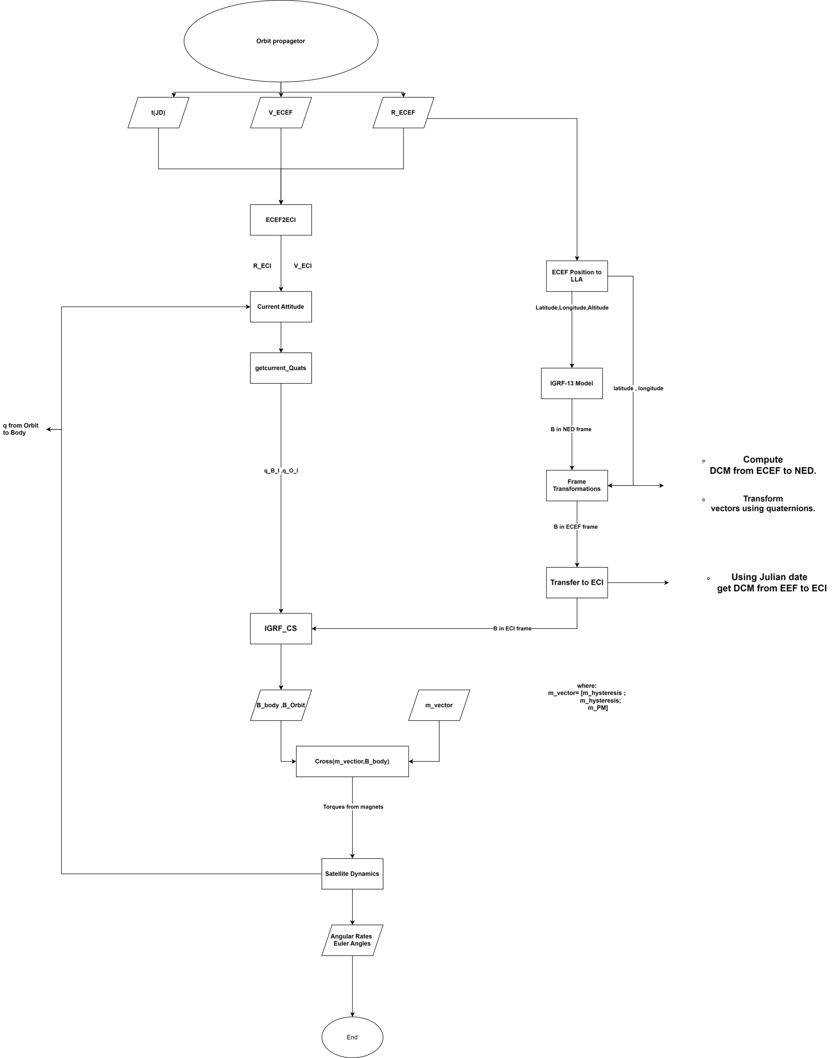

## 8.11. Results

Tesseract

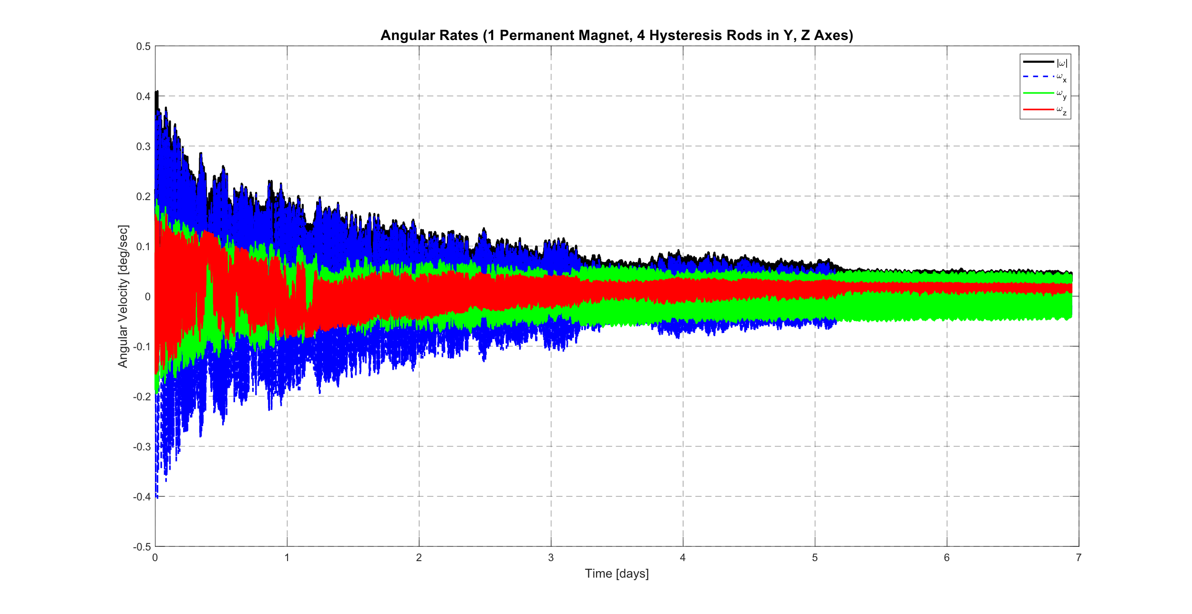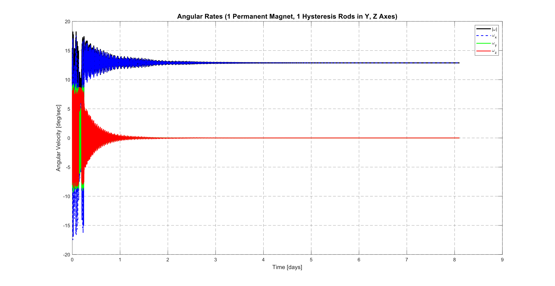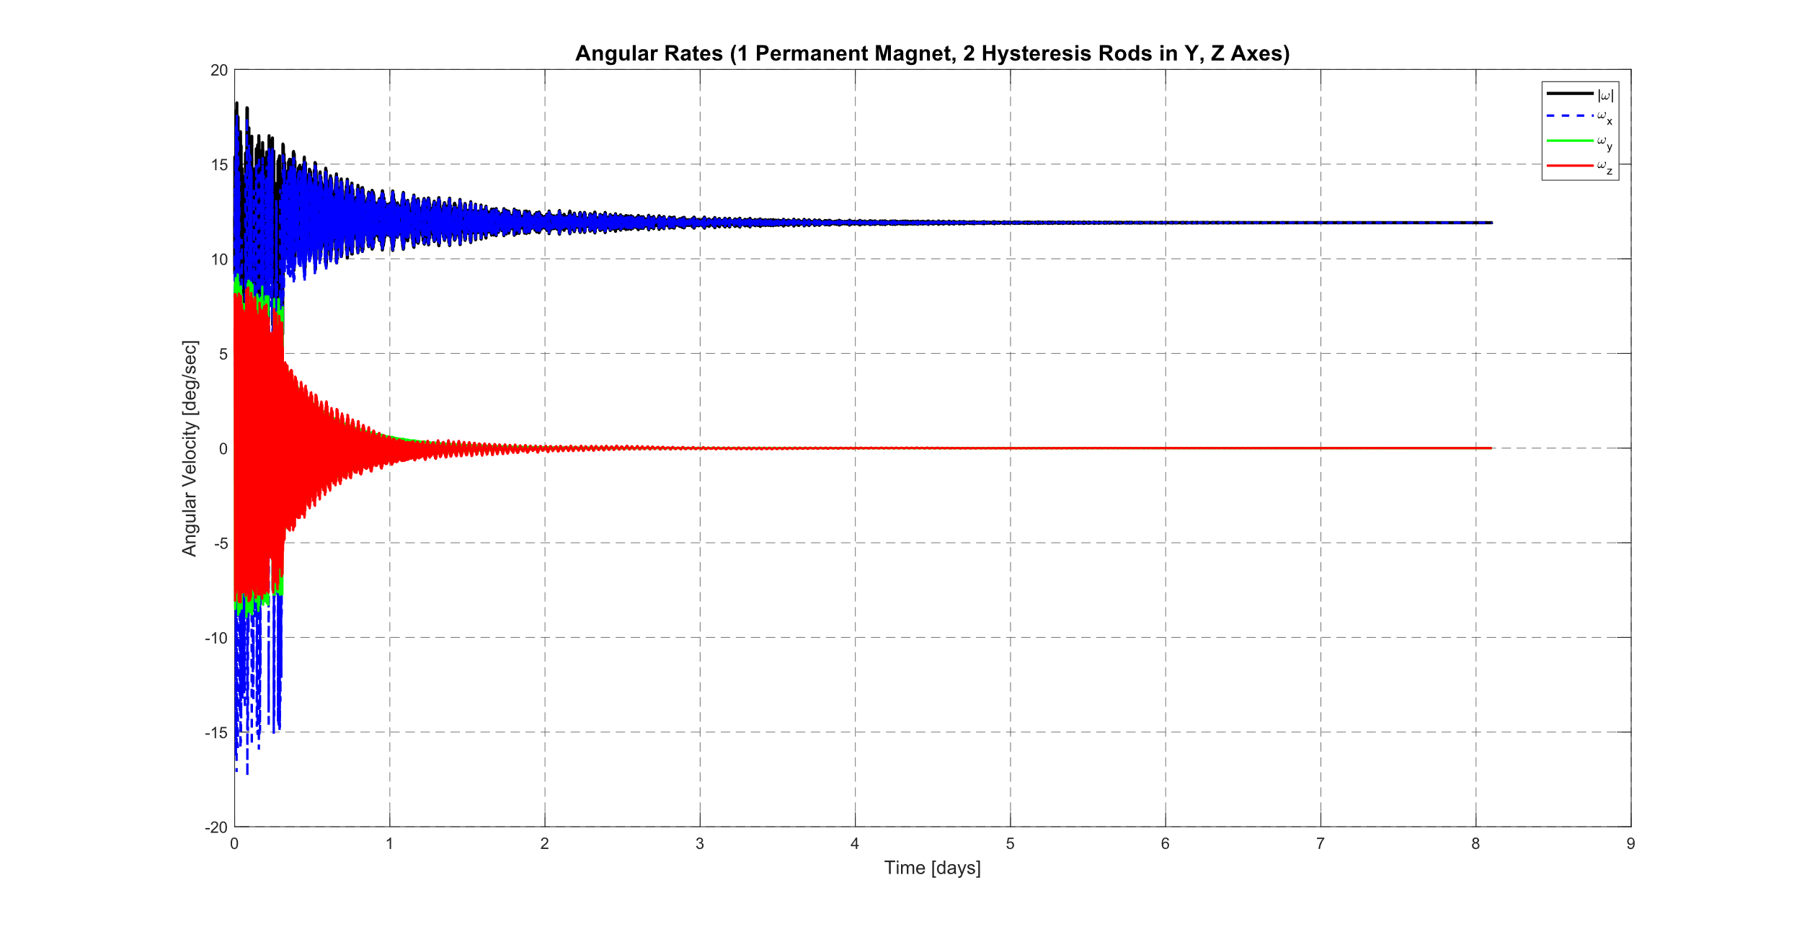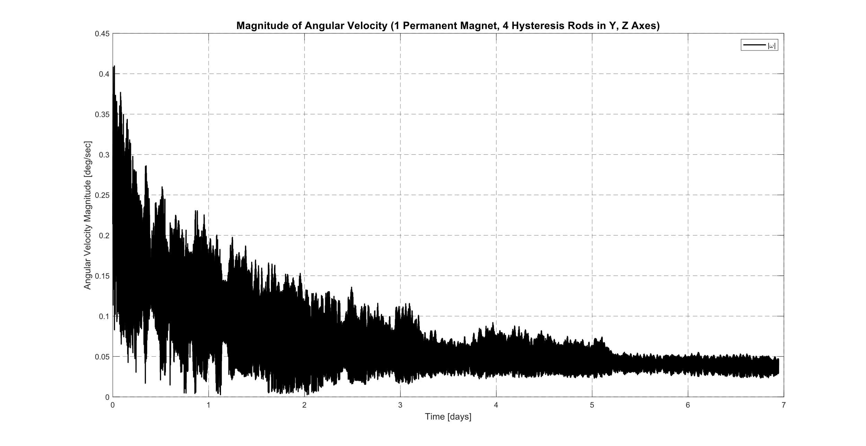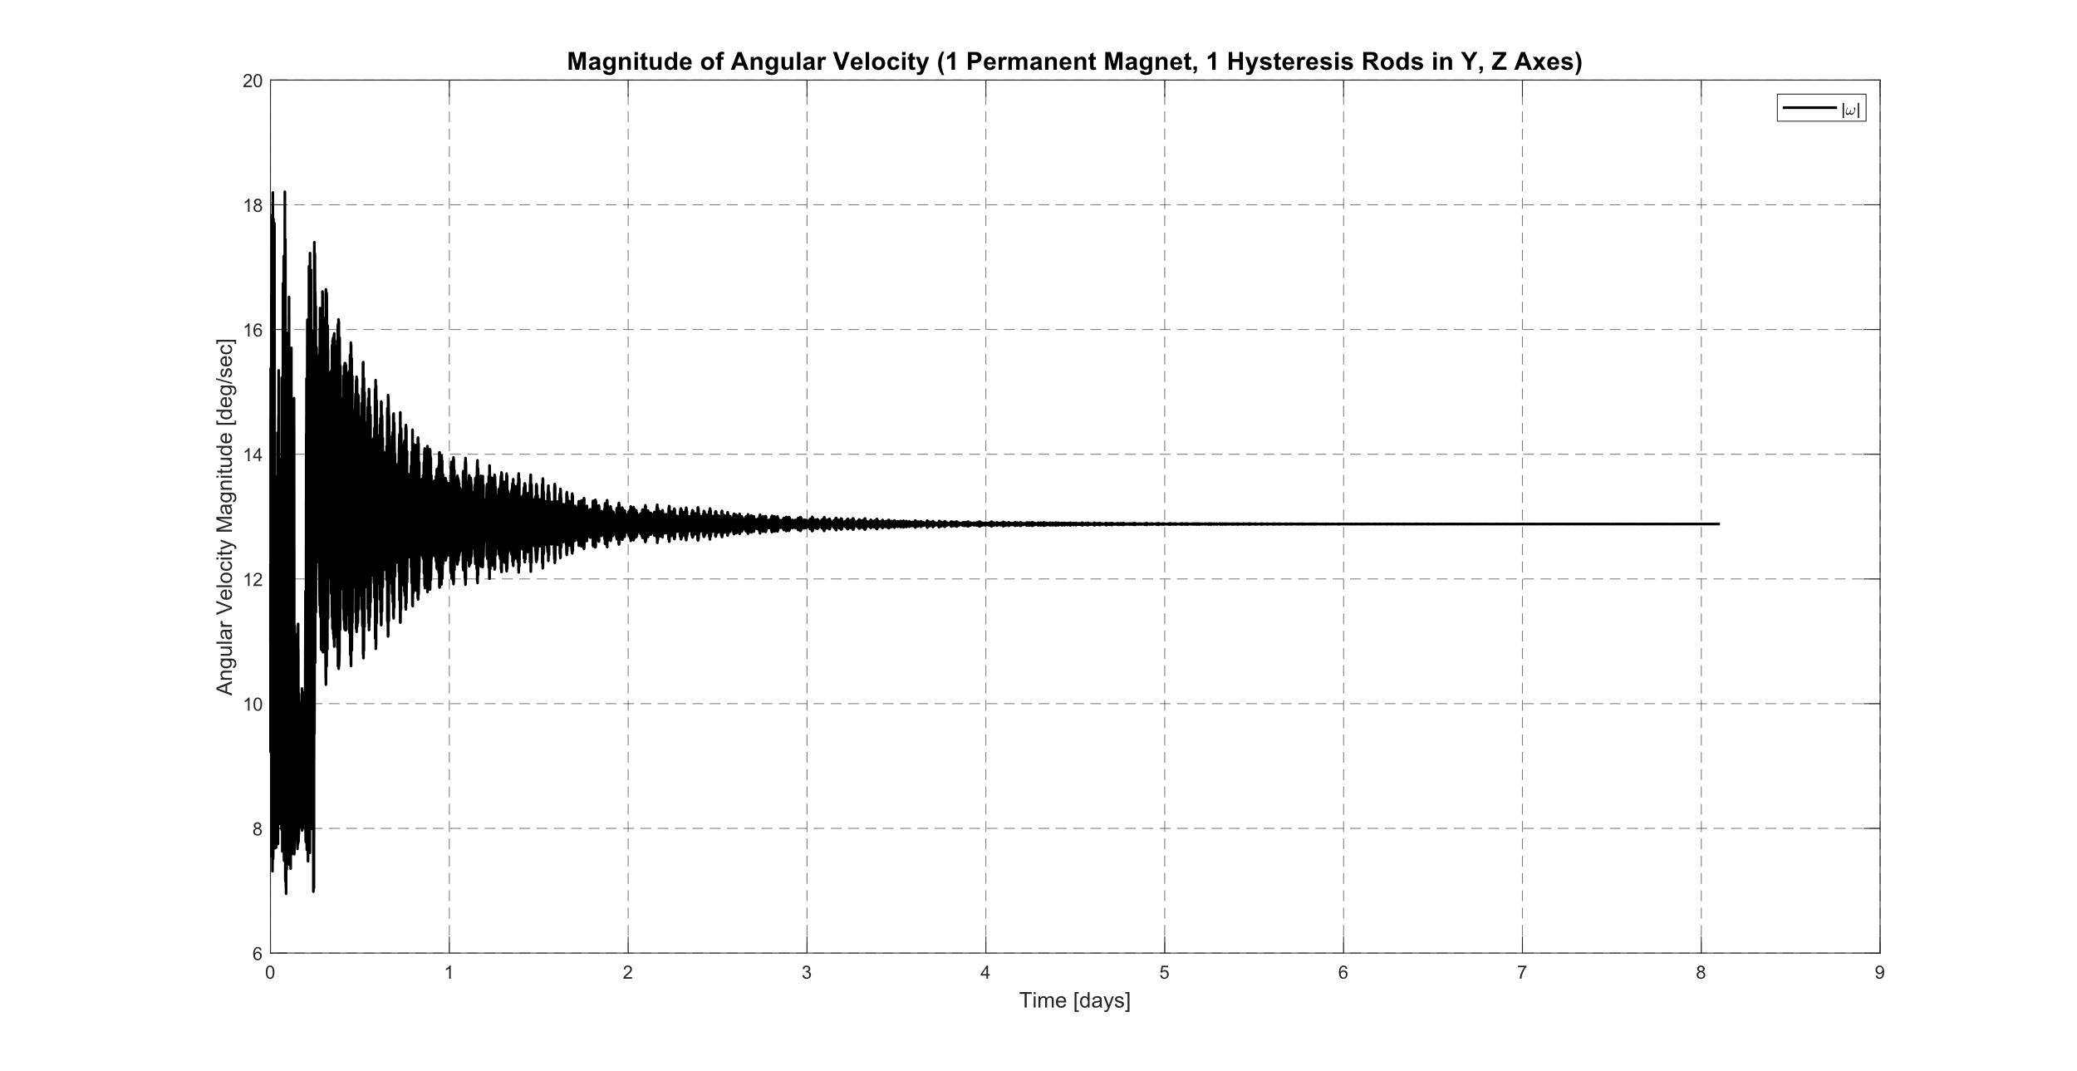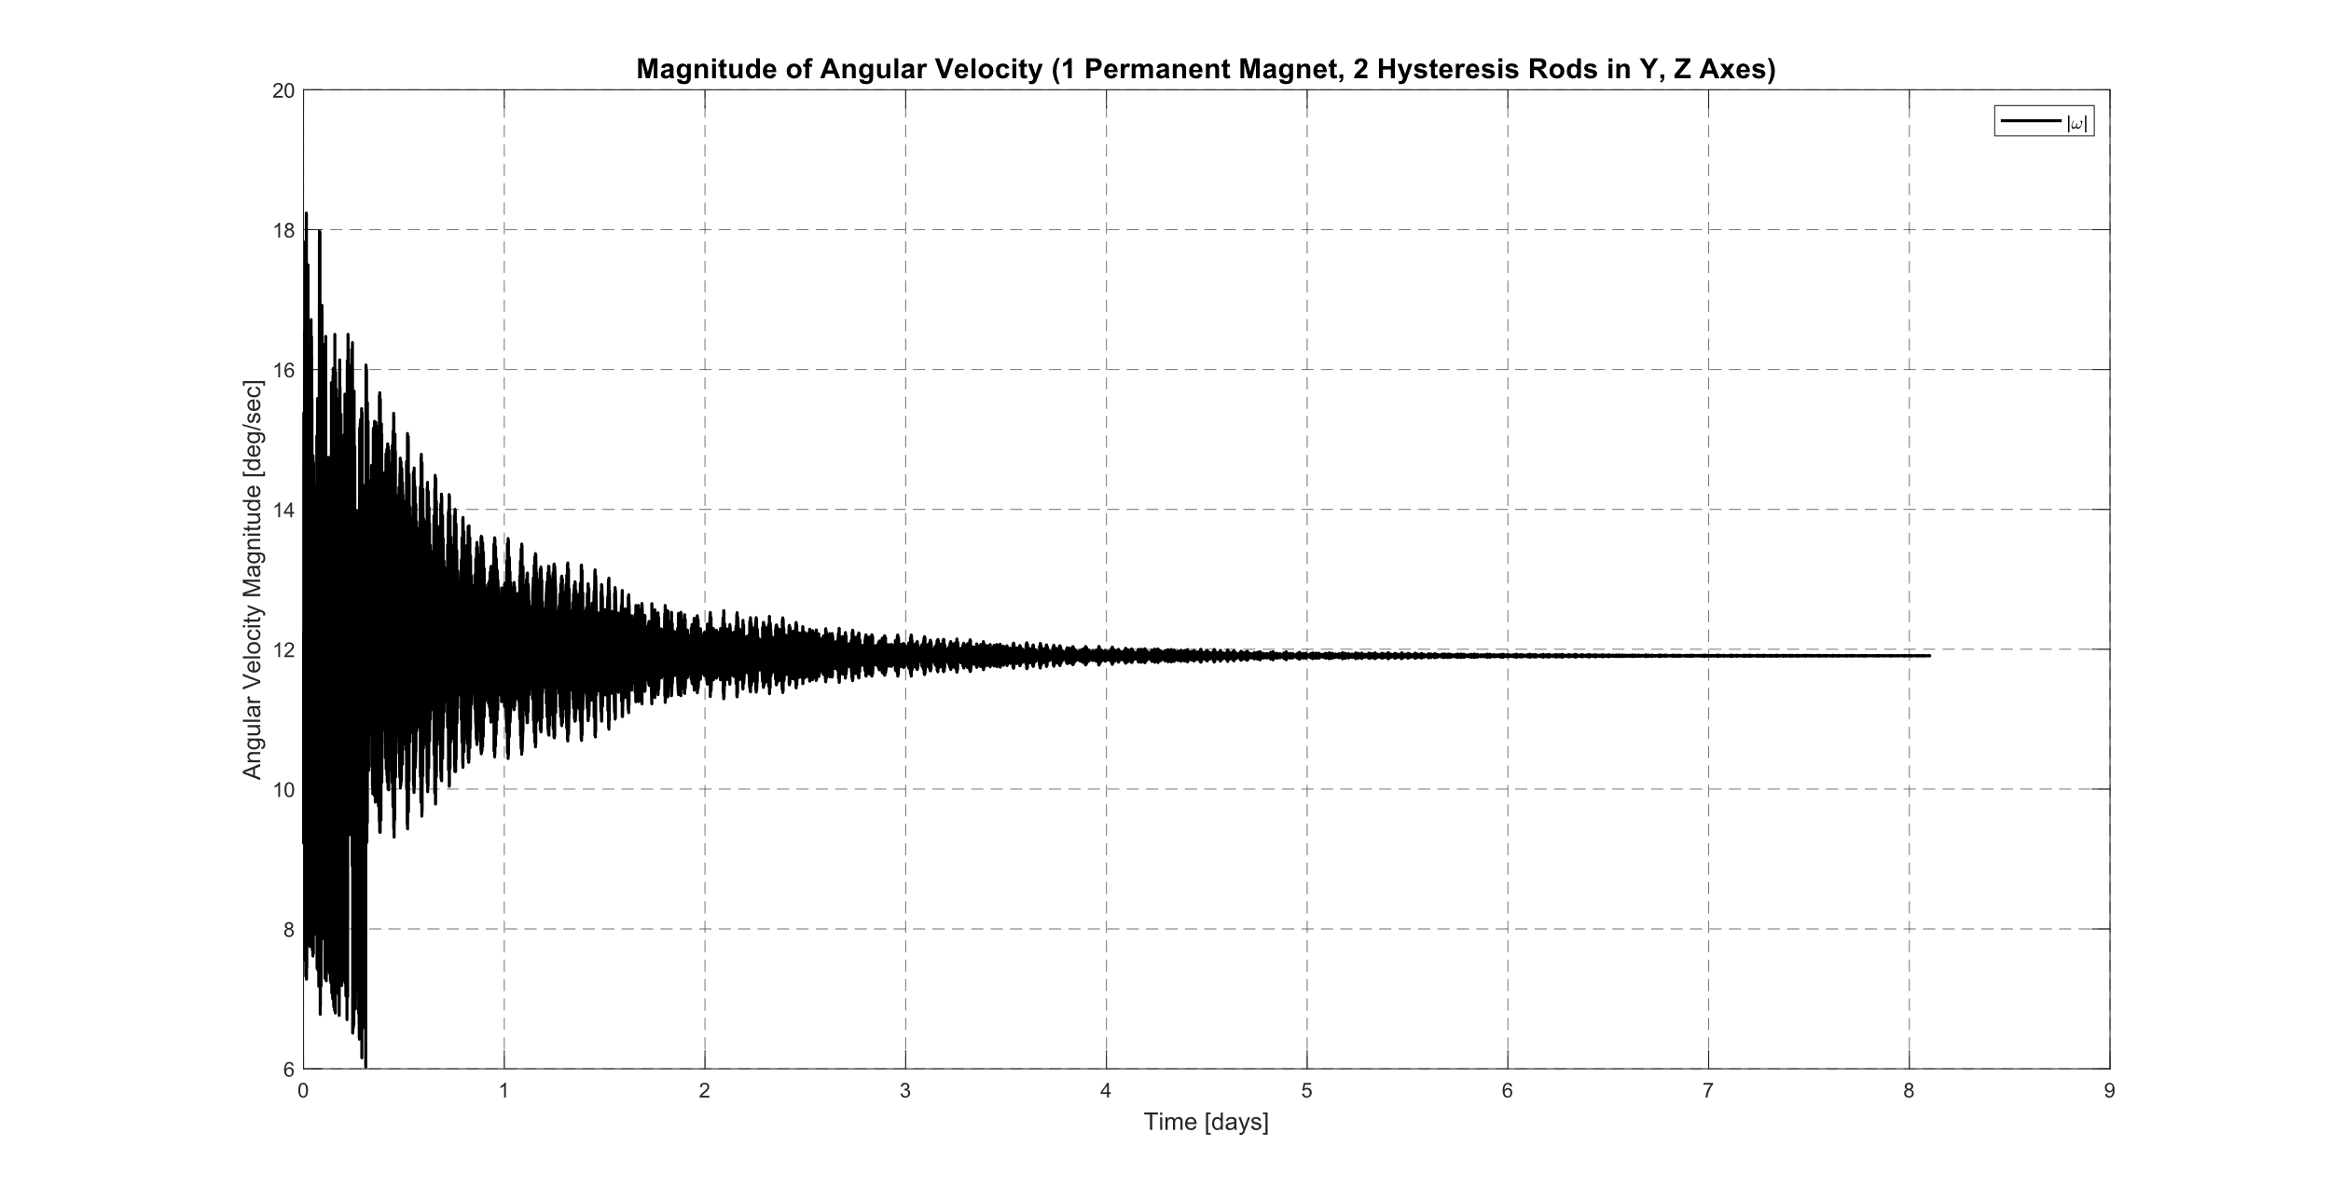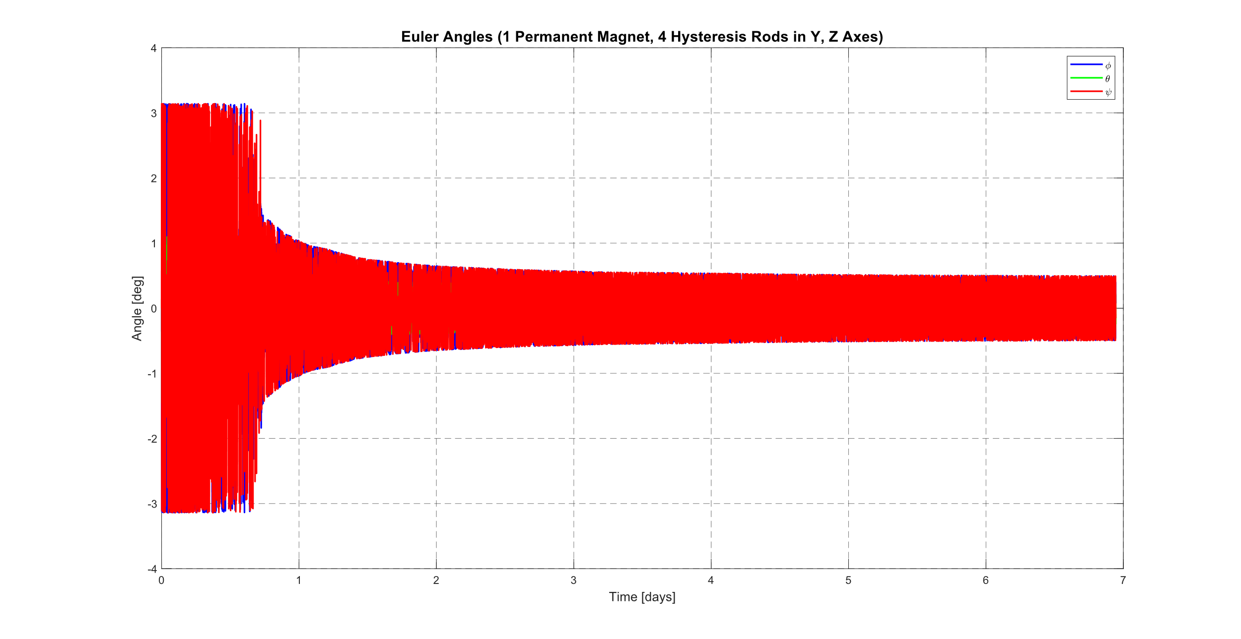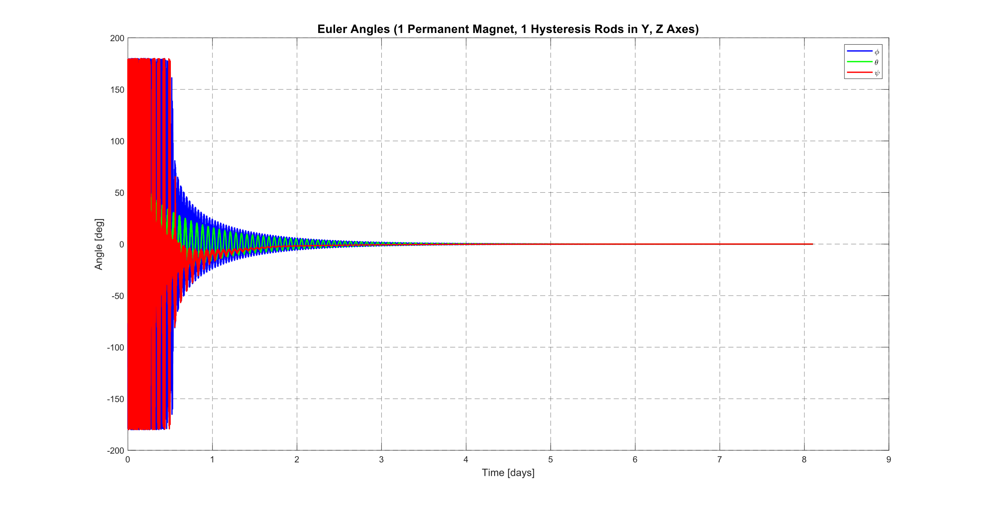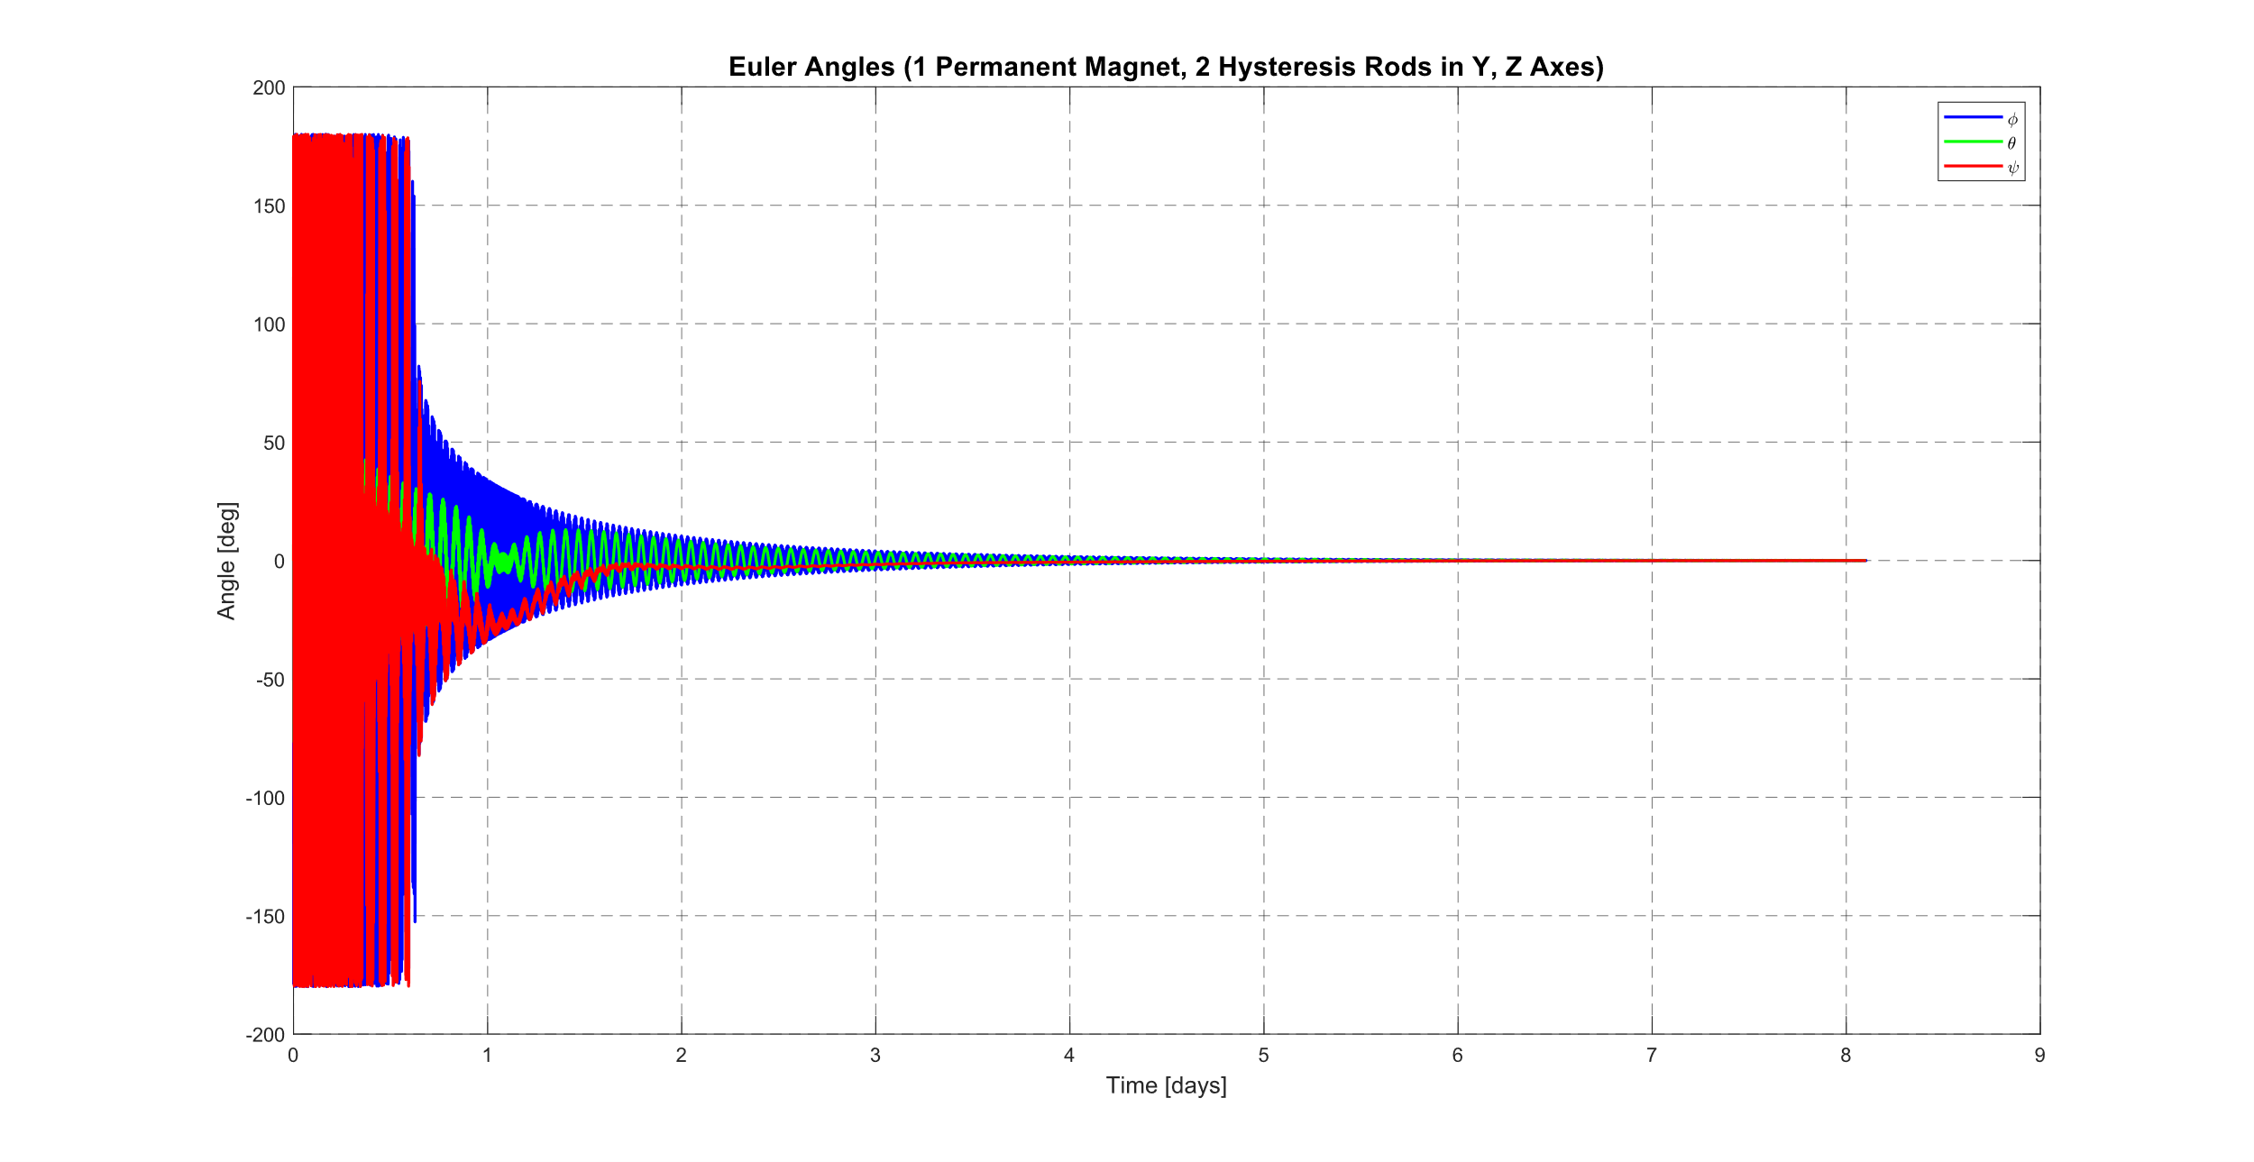

CSSWE

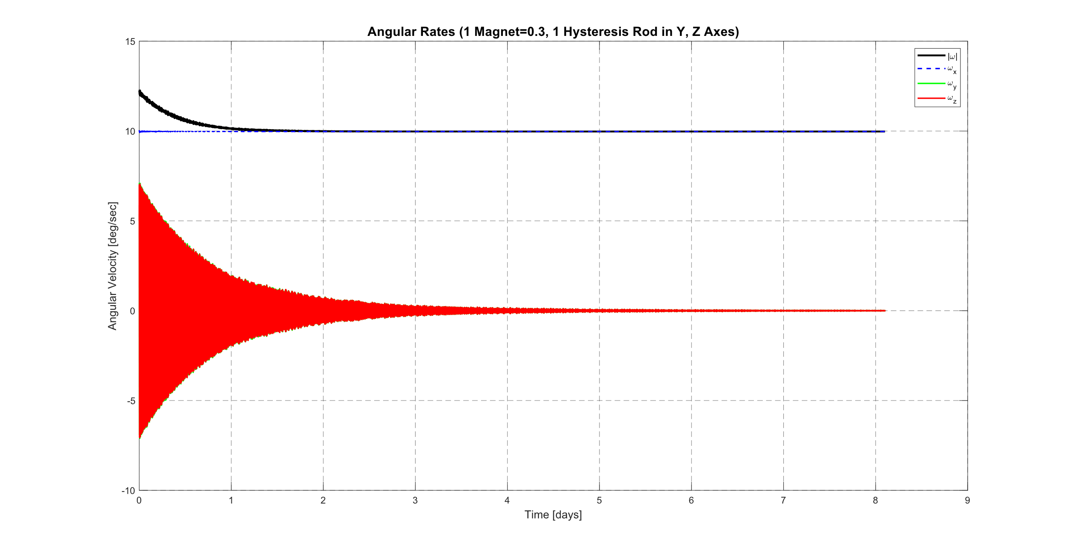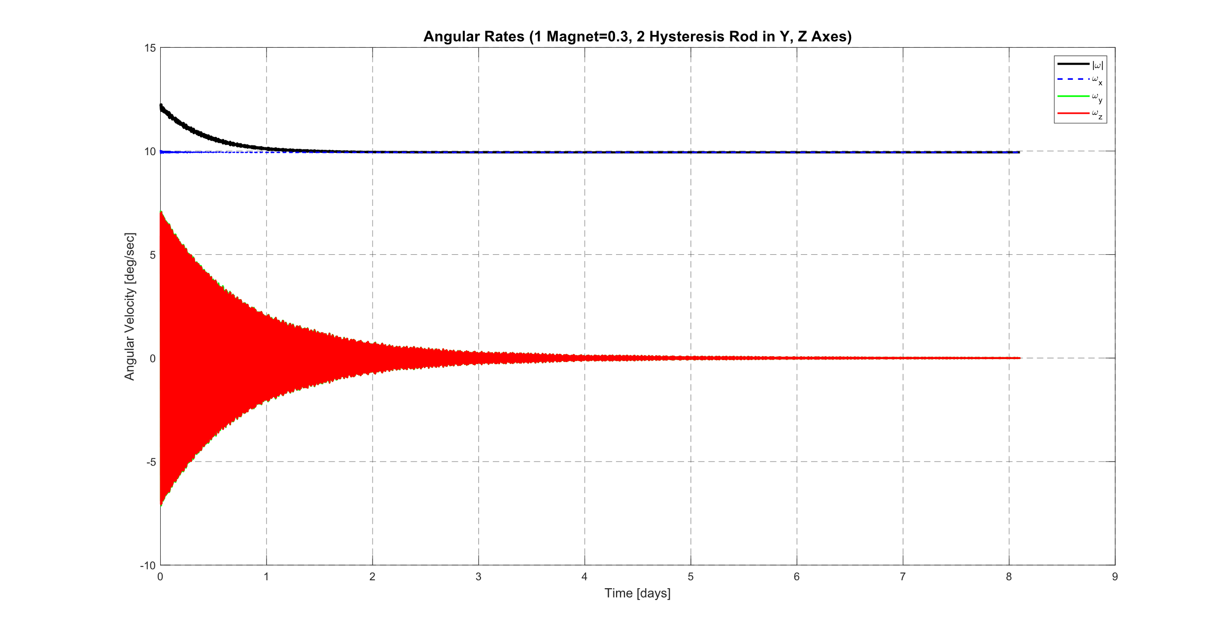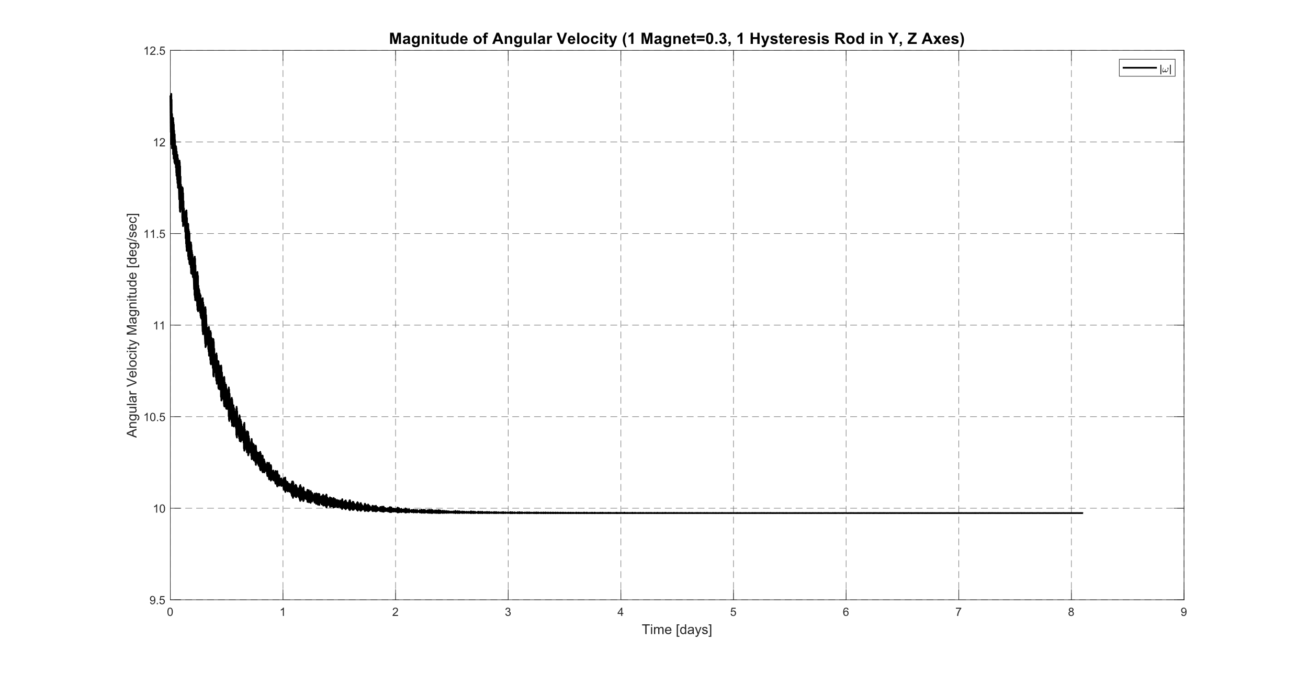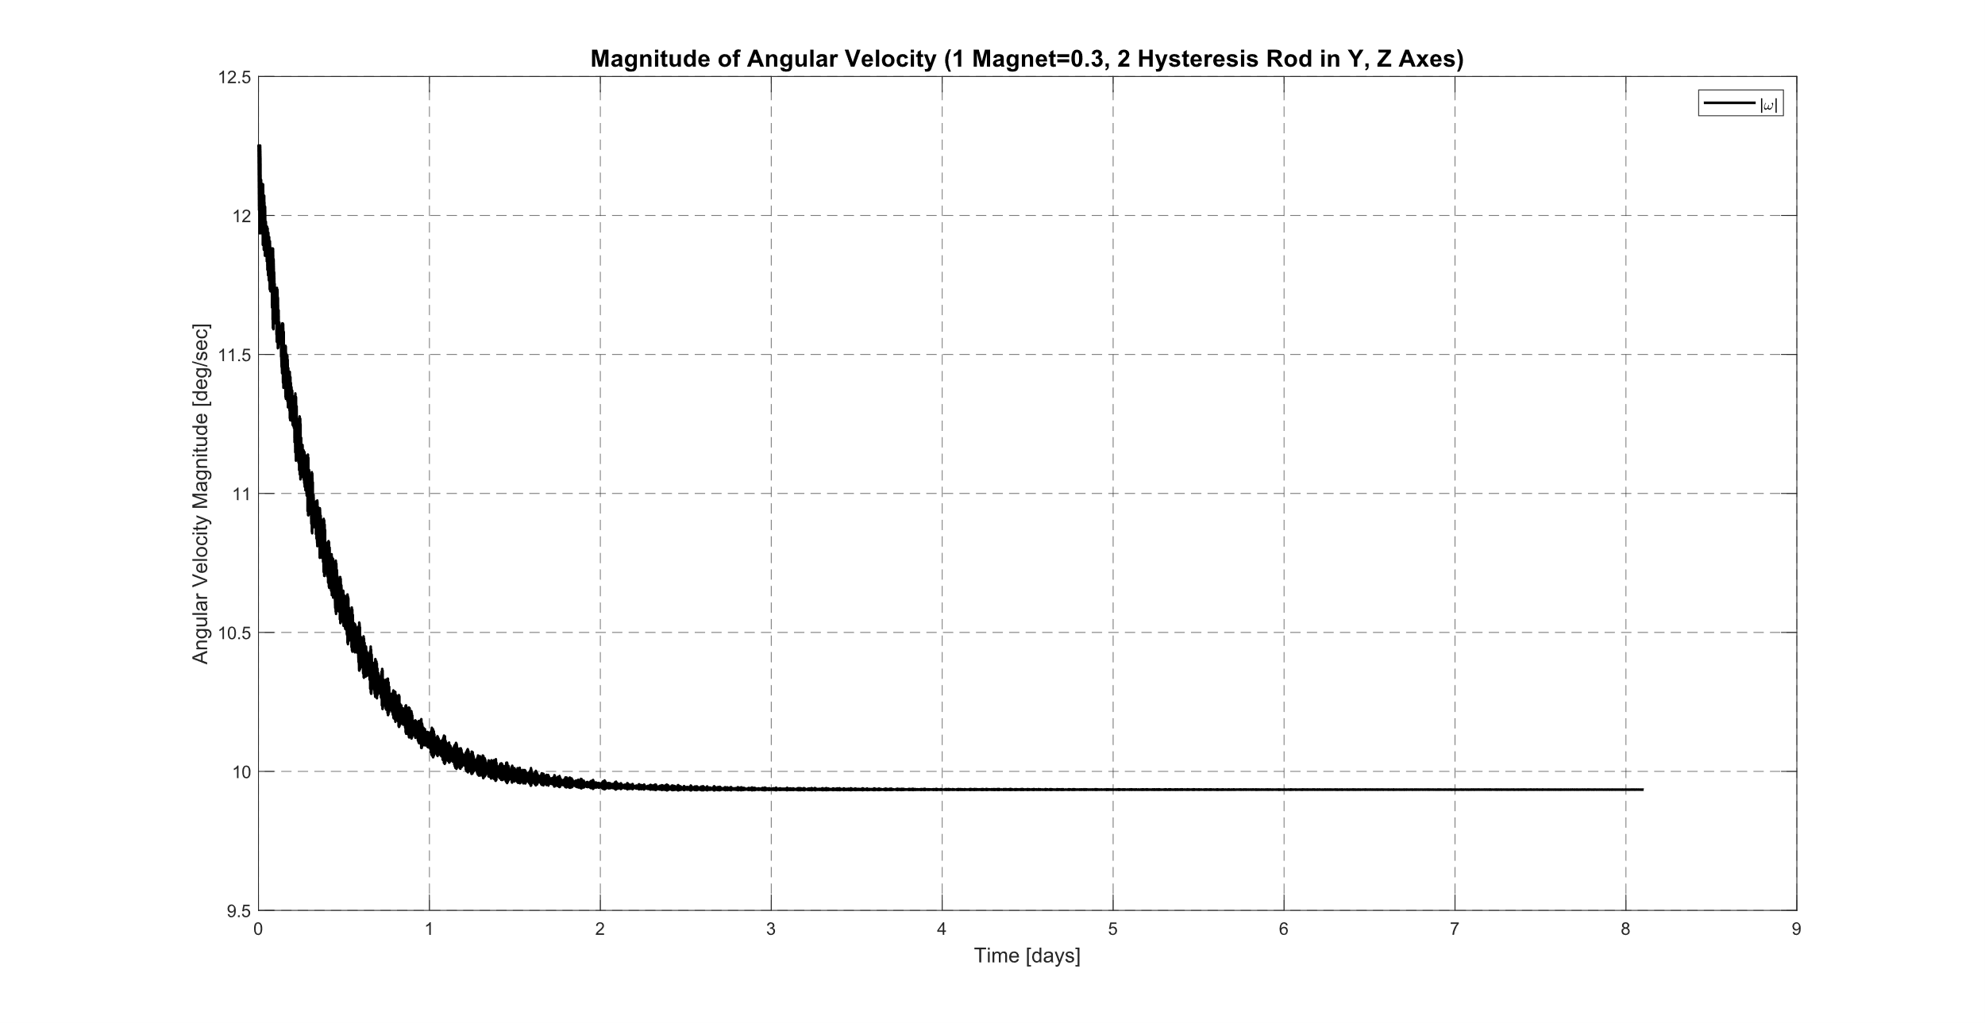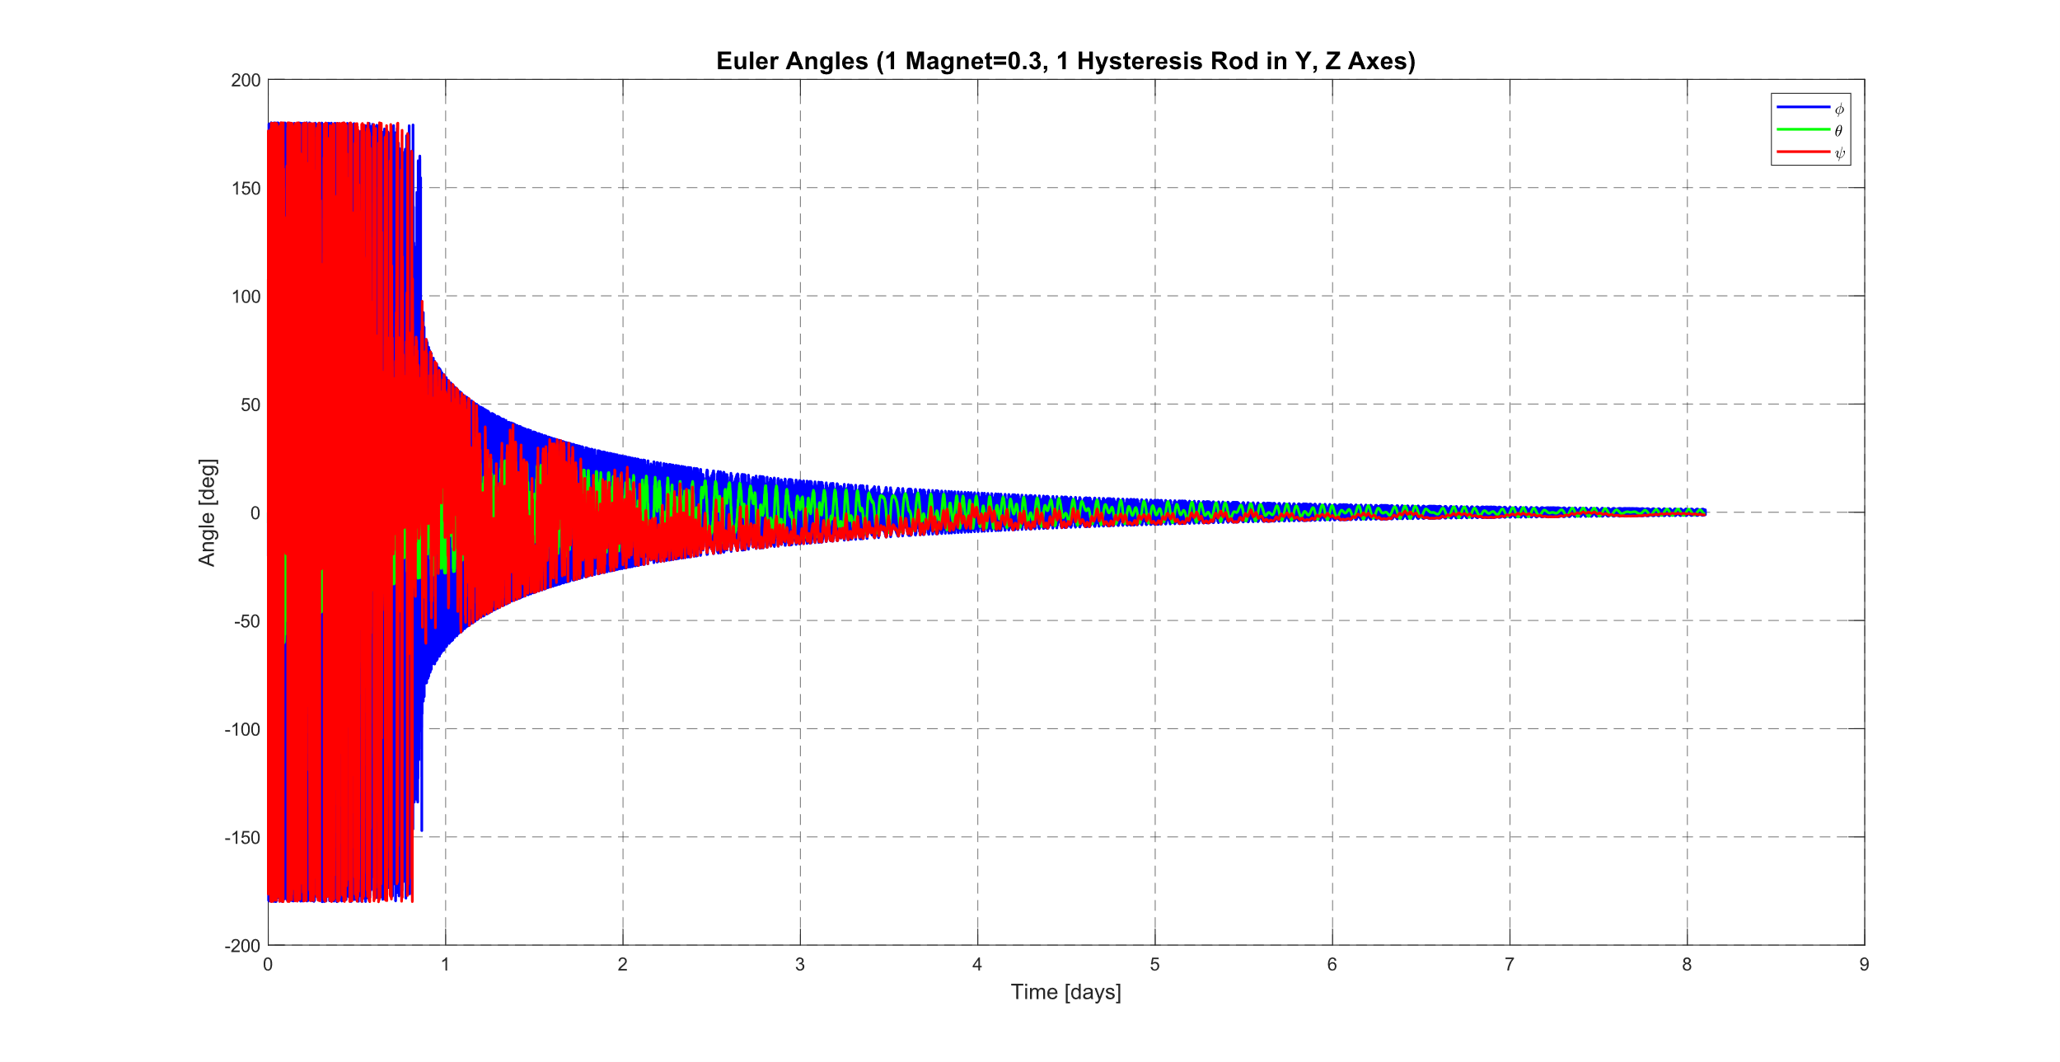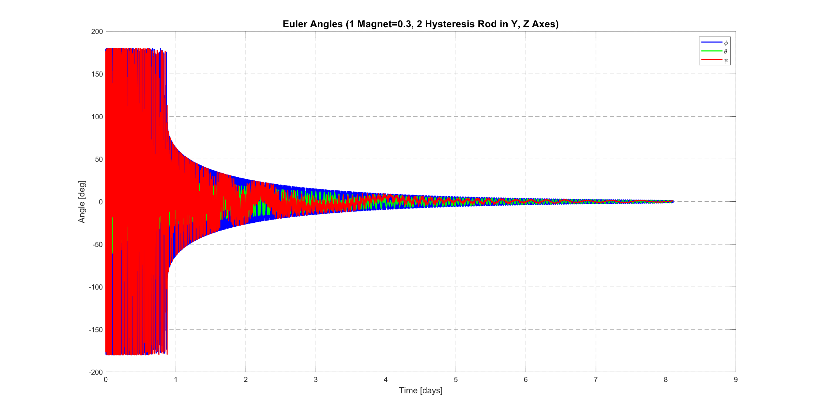

## 8.12. Conclusion

## 8.13. References

# IoT GROUND SENSORS

**9**

**CHAPTER**

# SYSTEM INTEGRATION AND TESTING

**10**

**CHAPTER**

# CONCLUSION

# FUTURE WORK

# REFERENCES

# APPENDICES

## Appendix A: